A framework for understanding the process of gaining web survey response using only postal contact
Gerry Nicolaas & Patten Smith
Ipsos MORI, UK

Background
Similar to what has been observed elsewhere, we are witnessing an increase in the use of push-to-web surveys in the UK for official statistics, including plans for the UK Labour Force Survey and the UK Census in 2021.
Initially the response rates for push-to-web survey designs in the UK were promising. Experiments with this design on the Community Life Survey (UK Cabinet Office) and the UK European Social Survey suggested that online response rates of 25% were feasible with the option of increasing the overall response rate further by offering an alternative data collection mode to web non-respondents. Since then, however, the UK survey industry has struggled to achieve this level of online response. For example, the Active Lives Survey (Sport England) achieves an overall response rate of about 19% compared to 31% for the Community Life Survey with a similar design; i.e. address-based, 3 mailings, £5 conditional incentive, and a postal option among online non-responders. In his overview of push-to-web surveys carried out by Kantar Public in the UK, Williams quoted response rates ranging from 9% to 24% (averaged across different experimental conditions). He concluded that the identity of the sponsor and/or topic of the survey, appears to make a significant difference to the response rate. However, more evidence is needed to understand this wide variation in push-to-web response rates and to find methods for improving the online response rates.
In this paper, we present a framework for understanding the process of gaining web survey response when solely relying on postal contact. We initially developed this framework to support our discussions with a client about what we should focus on in our efforts to increase the response rate on their push-to-web survey. However, it also proved useful for our colleagues working on push-to-web surveys, highlighting that there is no silver bullet for solving the non-response problem. Instead they need to focus on all stages of the process and the connectivity of these stages.
At this workshop, we would like to explore with you whether this framework could also be used as a tool for summarising the existing evidence and identifying gaps in our knowledge.

The framework
The framework is strongly influenced by the Tailored Design Method for implementing postal surveys and it has three key features:
- It takes the perspective of the target respondent;
- It breaks down the survey response process into different stages of gaining cooperation;
- It focuses on survey design features that can be manipulated.

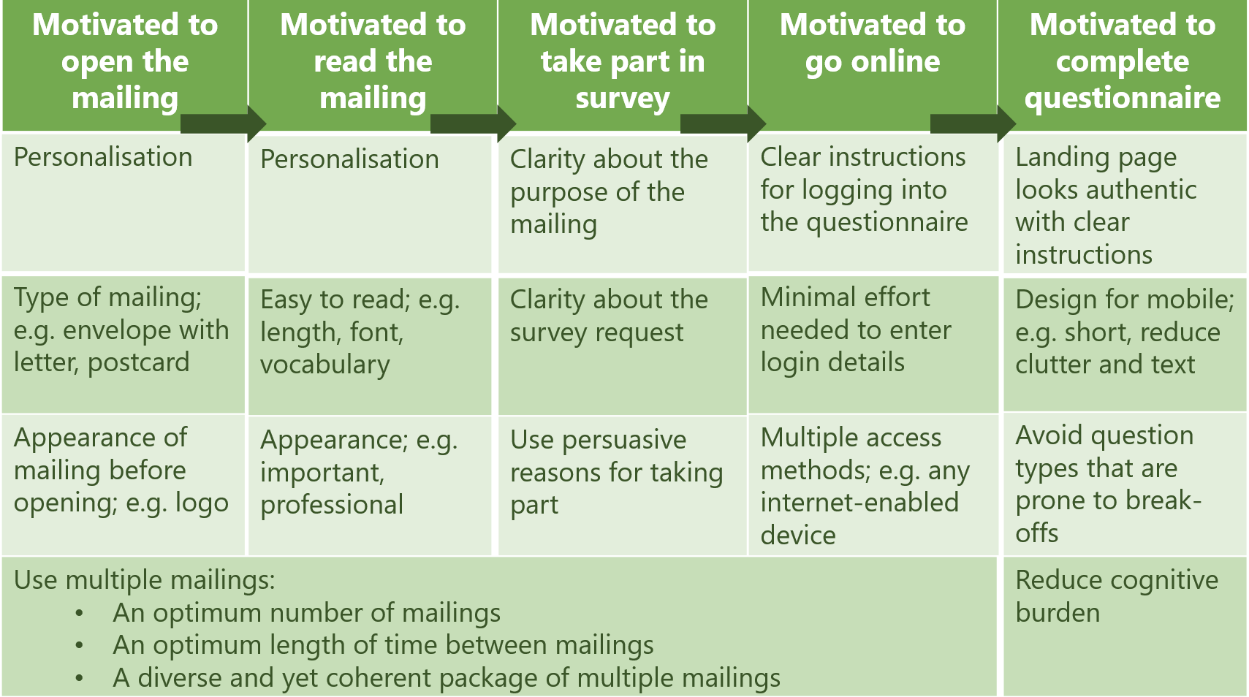

Summarising the existing evidence and identifying gaps in our knowledge
We do not have the resources to conduct a proper review of the literature. However, for illustrative purposes only, we have used the framework to summarise our own knowledge of the literature and experience.

We are fairly confident that the following has a positive impact on push-to-web surveys (all other things being equal):
Motivated to open the mailing | - Personalisation when names are available  - Logos when using address-based samples without names
Motivated to read the mailing | - Personalisation when names are available
Motivated to take part in the survey | - Incentives  - Alternative mode for web non-respondents
Motivated to go online | - Multiple access methods
Motivated to complete questionnaire | - Avoid complex question formats  - Avoid cognitively difficult questions
Optimal package of communications | - Multiple and varied contact attempts

Areas that lack evidence or the evidence is mixed:
Motivated to open the mailing | - Type and appearance of mailing (particularly for unnamed samples)
Motivated to read the mailing | - Visual design and first impression of the letters
Motivated to take part in the survey | - Which (combination of) persuasive messages?  - Type of incentives (considering cost effectiveness)  - Respondent selection instructions for address samples⁷
Motivated to go online | - Reducing the effort of moving from postal contact to online questionnaire completion
Motivated to complete questionnaire

Optimal package of communications | - The operational connectivity among the different stages of gaining cooperation (Dillman, ESRA 2017)⁴
Questions for discussion
- Is the framework comprehensive? Have we missed anything?
- Is it useful as a practical tool for maximising online survey response when relying on postal contact methods?
- Is it a useful tool for summarising existing evidence, identifying gaps in knowledge, and prioritising further research? If so, what is the next step?
- What are the priorities for further research?

TNS BMRB (2013). Community Life Survey: Summary of web experiment findings. A report for the UK Cabinet Office. https://www.gov.uk/government/uploads/system/uploads/attachment_data/file/325872/Annex_B_-_Summary_of_web_experiment_findings_2012-13.pdf
Humphrey, A. (2013). ESS Mixed Mode Experiment. Presentation given at the European Survey Research Association 2013 conference, 16-19 July 2013, Ljubljana, Slovenia. https://www.europeansurveyresearch.org/conference/programme?sess=89#506
Williams, J. (2017). An introduction to address-based online surveying. Social Research Practice, Issue 3 Winter 2016/17, pp. 23-35. http://the-sra.org.uk/wp-content/uploads/social-research-practice-journal-issue-03-winter-2017.pdf
Dillman, D.A. (2017). The worldwide increase in use of web-push methods that start with a mail contact; what have we learned and where might we be going? Presentation given at the European Survey Research Association 2017 conference, 18-21 July 2017, Lisbon, Portugal.
Dillman, D.A., Smyth, J.D., Christian, L.M. (2014). Internet, Phone, Mail and Mixed-Mode Surveys: The Tailored Design Method, 4th edition. John Wiley: Hoboken, NJ
We are presenting some of our work in this area at the workshop. See “An experimental of methods for increasing response rates in a push-to-web survey of sport participation”, Patten Smith.
We are presenting some of our work in this area at the workshop. See “The viability of a push-to-web survey design in 28 EU member states: the new Fundamental Rights Survey”, Gerry Nicolaas et al.

