**Testing incentive strategies to improve response on ONS social surveys**

1. **Background**

Incentives are widely used across social surveys in the UK and overseas. These include monetary incentives (such as cash or vouchers) and non-monetary incentives (such as pens or entries in prize draws).

Incentives are used:

* to maintain (or ideally increase) response rates;
* to reduce the costs of collection; and
* to compensate for the burden being placed on respondents.

Incentives can be used in two ways (one or both):

* as a gift given regardless of whether the respondent participates, to encourage participation on the basis of reciprocity (unconditional);
* to acknowledge respondents' contribution when given on completion of the interview (conditional).

The use of incentives is commonplace in government sponsored surveys in the UK.

1. **Evidence for the Use of Incentives**

There is strong evidence in the literature on survey methodology that incentives increase survey response rates. This is summarised in Survey Methodology (Groves et al, 2009):

* offering an incentive to participation increases cooperation rates
* monetary incentives have a bigger impact than non-monetary incentives
* pre-paid (unconditional) incentives are more effective than promised (conditional) incentives
* some studies suggest that response rates increase with the value of the incentive but at a decreasing rate (diminishing returns)
* if the incentive effect is powerful enough, total costs may decline because of lower interviewer or reissue costs
* they have a greater effect where response rates without an incentive are low
* some studies show that incentives affect the participation of persons who are less interested in the survey topic

In 2013 Singer and Ye reviewed research on incentives in their article, "The Use and Effects of Incentives in Surveys" (published in The Annals of the American Academy of Political and Social Science) by systematically reviewing articles appearing since 2002 in major journals. The article's conclusions confirm Groves' findings and add:

* Incentives increase response rates to surveys *in all modes*
* There are few studies about the effect on quality of response. Most which have been done found no effect, but more research is needed
* Monetary incentives provided in advance seem to impact the demographic composition of the completed sample
* Incentives therefore have potential for increasing and reducing non-response bias, but better information is needed about the mechanisms by which non-response bias comes about before they can be used to target non-response bias

Additionally, in 2000, Singer reported that it is possible that interviewers expect respondents who have received an incentive to be more cooperative and therefore may feel more confident about approaching such a household. This may result in them being more effective in their interaction with the potential respondent[1].

ONS's use of incentives is based on this body of survey methodology research, which is regularly updated as survey researchers explore the effects of variations in the value and use of incentives. The evidence has been supplemented by in-house research to assess effects on ONS surveys and possibilities for additional use of incentives. The use of incentives is reviewed on a regular basis, in the light of developments in the wider survey world as well as studies on ONS surveys.

1. **The Current Use of Incentives on ONS surveys**

Participation in ONS household surveys is voluntary and incentives with monetary value (stamps or vouchers) are used for many of these surveys.

Unconditional incentives used to be a book of six first class stamps but, since July 2015, a book of four second class large letter stamps has been commonly used[2]. Where a voucher is issued as an unconditional incentive, this is usually a £5 high-street voucher (*Love to* *Shop*). This is a voucher that can be used in a variety of high street shops, so what the recipient uses it for is at their discretion. It is widely accepted that there will be a deadweight loss from using an unconditional incentive. Because it is being issued to all households, you are giving money to those who would have taken part anyway, and you are also giving it to those who will never take part regardless of the incentive that you use. There are also those households that are ineligible and those households who throw the letter away without opening it, although a small proportion of respondents do return an unconditional incentive when they refuse!

The Family Resources Survey (FRS) is currently the only survey where ONS uses a larger value Post Office Payout (POP) voucher, in this case of £10. A higher value POP voucher can be offered, because vouchers which are not redeemed are not fully paid for, and therefore the cost of issuing a £10 POP voucher is similar to issuing a £5 Love to Shop voucher and there is less of the deadweight loss mentioned above. ONS have not currently done any research looking at the impact of the POP voucher compared to the more traditional Love to Shop voucher.

Conditional incentives used on ONS surveys are generally of greater value (most commonly a £10 voucher) than unconditional incentives. They are used on surveys which place a heavier demand on the respondent in terms of the length of interview (Wealth and Assets Survey(WAS)) or the requirement to complete a diary (Living Costs and Food Survey (LCF)), or on longitudinal surveys where we are trying to gain the respondent's long-term commitment to the survey (WAS and Survey of Living Conditions (SLC)).

The incentives ONS use typically have a monetary value, but interviewers report that unconditional incentives in particular may have another less transactional value, with respondents either spontaneously remembering the book of stamps included with the advance letter or only remembering the advance letter when the interviewer mentions the stamps. It is therefore likely that the secondary value of an unconditional incentive is as a memory aid to respondents.

1. **Latest incentive trial results**

In recent years, ONS have investigated several incentive options in an effort to boost response and in some cases save money. This has also allowed us to gather more information about which incentives work best, and in which areas. The work done is summarized below.

* 1. **Introducing a £5 unconditional voucher to poor response areas**

An unconditional incentive (£5 *Love to Shop* voucher) was tested in selected areas for Wave 1 of the Labour Force Survey (LFS) from October 2016 to June 2017. For the selected areas, any sampled address received this voucher with the advance letter that is sent out to all households prior to the start of the field period. Prior to this, no incentive has historically been used on the LFS except for a book of stamps sent out with the advance letter in August and December each year (‘holiday’ months when response can be particularly challenging)

Areas were selected to take part in the test under a number of conditions:

1. areas that were failing precision targets[3]
2. areas that have taken part in a project to improve local area response rates on LFS but their response has not improved sufficiently
3. areas that have had a large drop in response in the last five years or a consistent smaller drop over the last five years but due to resource haven't been included in the above project yet
4. areas that had a low absolute response in the preceding year

The results of this trial are summarized below:

* Response rate in the areas that received the incentive during the trial period was significantly higher (approximately 3 percentage points) than response for the same areas during the equivalent period the previous year (October 2015 – March 2016). This was mainly due to a decrease in the refusal rate.
* Although this wasn’t a split sample trial, the trajectory of response is generally downward and therefore we are fairly confident that the increase in response over time in the areas taking part in this test is a positive effect of the incentive.
* In the pre-trial period interviewers made on average 3.3 calls per case in “incentive” areas and during the trial this reduced to 3.1 calls per case. This change was statistically significant.
* Response has increased particularly in certain types of areas and decreased in other types of areas[4] but it is difficult to say whether these changes are statistically significant due to small sample sizes in lower geographic areas. More research is needed to gather evidence on the impact of an unconditional incentive across demographic groups and whether that impact is significant.
  1. **Testing two different unconditional incentives**

On the Survey of Living Conditions stamps were tested against a £5 love to shop voucher (as an unconditional incentive) from January 2017. Initial results show that there was no difference in response between the group who received the stamps and the group who received the vouchers. Additionally, the average number of calls per case was similar for each of the groups, which suggests neither incentive results in the interview being obtained more quickly.

This helps to back up the anecdotal evidence from interviewers about unconditional incentives acting as a memory aid, and in this case, the increased monetary value of the voucher has not resulted in a higher response rate or a more efficient data collection. More analysis is being done to look at whether there was any impact on efficiency of data collection or different results by demographic group.

* 1. **Increasing the value of a conditional incentive**

From August 2016 the conditional voucher on the Living Costs and Food Survey has been increased from £10 to £20.

This resulted in a significant decrease in refusals when comparing to the same time period last year (2 percentage points less). Although there was a slight increase in response rates, this change wasn’t significant, but analysis has indicated that if the incentive hadn’t been increased to £20, response rates would have declined further. Again, this wasn’t a split sample trial but the general response trajectory is downward and therefore response stabilising suggests the incentive had a positive effect. More work is planned to analyse the impact of this change on different demographic groups.

* 1. **Using an unconditional voucher on the first call if no contact is made**

A small scale trial was tried out from November 2015 to February 2016 where interviewers were issued with £5 vouchers to post through a respondent’s door with a calling card if no contact was made at the first call. The calling card encourages them to phone our Survey Enquiry Line to make an appointment, so the idea of leaving a voucher with that was to help persuade respondents to take that action. The aim of the trial was to assess whether this was more cost effective (despite using a voucher) than interviewers making several calls to try and make contact. Unfortunately, there were operational issues resulting in the trial being paused. It was difficult to develop audit and tracking procedures that are compliant with legal audit requirements. Additionally, it has become clear that interviewers were not using the voucher as intended, and were using it more as a “bargaining tool” on the doorstep – so as an unofficial conditional incentive. We therefore haven’t been able to evaluate the effectiveness of leaving an unconditional voucher on the first call where no contact is made.

Interviewers often feed back that they’d like to have a stack of vouchers to use as necessary on the doorstep, but with the complicated audit requirements, this has so far been resisted. It would be interesting to hear if any other survey organisations have experience of allowing interviewers to give out vouchers, and if so, how they have found it’s worked.

1. **Future incentive plans**

As well as the trials that have happened recently, there is also other research being carried out currently, or planned, which will add to our body of research on incentives, and inform future strategies for maximising response. We are interested in hearing thoughts on how we evaluate these trials, as well as any ideas for future testing.

* 1. **Testing differing amounts of an unconditional voucher**

Following the trial of the £5 unconditional voucher on the LFS, funding was agreed to roll out an unconditional incentive on all Wave 1 addresses selected for the LFS. This was started in June 2017, with half of areas receiving a £5 voucher and half of areas receiving a £10 voucher.

Initial results show a positive result compared to preceding months, with response several percentage points up. However, due to typical month on month variation in response rates, we will be running this trial for several months to gather enough evidence about the impact of different values of unconditional incentives. We will be particularly looking at the impact in different types of areas, to establish whether introducing one of these incentive values results in a more representative sample.

* 1. **Testing a non-monetary unconditional “incentive”**

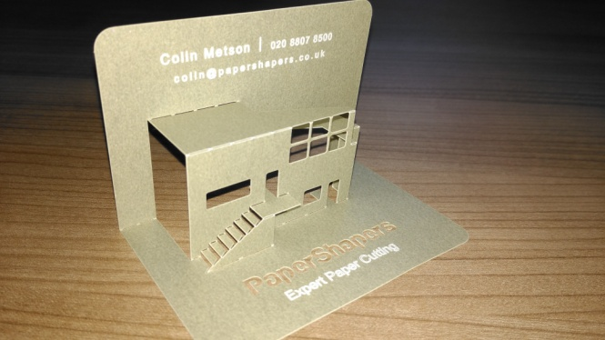

We are currently planning a trial where we issue “non-monetary incentives” in the form of pop-up cards included with the advance letter. Although these are technically not incentives, they might elicit some of the benefits of monetary incentives (namely how memorable they are) at a cheaper cost. See the picture to the right for an example of a pop-up card:

Work is underway to plan which surveys and what the trial design will be to test something like this. It is likely that they will be tested on more than one survey. Initial discussions have raised concerns about removing current unconditional incentives to test this idea (due to the risk to response rates) so a trial design may include a treatment group which receives the pop-up card in addition to an unconditional incentive vs a control group which only receives the standard unconditional incentive. Alternatively, or as well, the pop-up card may be tested on another survey where a conditional incentive is included at the end of the survey.

* 1. **Testing incentives for an online survey**

Additionally, with the work going on to move ONS social surveys online, we are going to be testing a number of different incentive options for a quantitative test planned for Autumn 2017 for online data collection on the LFS. The aim of this test will be to increase the uptake of those completing the survey online[5], to assess the impact of the incentive strategies on preventing attrition and to establish which incentive strategy is the most cost effective. For this test, addresses will be randomly split into four groups, with the options as follows:

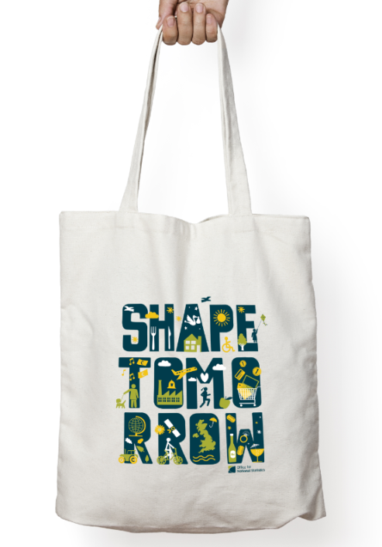

* No incentive
* £5 unconditional incentive
* £5 unconditional incentive and £10 conditional incentive on completion of the survey
* Tote bag with the design shown on the right:

More information on the testing conducted so far, and the future testing planned for online data collection within ONS will be discussed at a later session, led by Andrew Phelps.

1. **Conclusion**

It is clear there is still work to be done on gathering evidence about most effective incentive strategies; in terms of maximising response, minimising bias and lowering costs. We would like to hear whether other survey organisations have any insights they’d like to share on incentive strategies and to discuss any thoughts or ideas relating to the trials outlined in this paper.

1. We are interested to know whether anyone has experience of this, or of whether different types or amounts of incentives impact on interviewer behaviour differently?
2. A book of six second class stamps does not exist, and a book of four large letter stamps was cheaper at £3.04 than a book of 12 second class stamps at £6.72 or a book of six first class stamps at £3.90.
3. The precision targets were for the number of achieved interviews with economically active households
4. In particular, areas where residents are more likely to be aged over 65 and affluent (e.g. own 2 or more cars and live in a detached house or bungalow) were more likely to respond with the addition of an incentive. Additionally areas where residents are more likely to be Black, Black British, African or Caribbean, live in privately or socially rented flats, commute to work using public transport and live in densely populated or overcrowded areas were also more likely to respond with the addition of an incentive.
5. Andrew Phelps will be covering this in more detail in a later session, but initial take up for the first online test was 19.9% and we hope that introducing incentives will help to improve this.