# Use of targeted SMS and e-mails in a survey among applicants to child care centers in Oslo

### ***By Bengt Oscar Lagerstrøm[1] and Christoffer Holseter[2]***

Text messaging (SMS) and e-mail has through recent years become a normal way of communicating among organizations and citizens. Statistics Norway have increasingly used SMS and e-mail instead of traditional paper letters to inform and communicate with our survey respondents. This allow for exploration of how SMS and e-mail can be used as tools in the research process to influence data quality and data collection efficiency.

There are several advantages with digital communication. SMS and e-mails are cost-efficient ways of communicating, and has high coverage among citizens (Lagerstrøm 2015). Digital communication also has the advantage of “quick reach” as there is no postage time. These facts make SMS and e-mails suitable for both informing and reminding respondents about surveys.

The nature of SMS and email are different. Email have the advantage that there are few limitations coming to length and format, and you can also easily include direct-links. A limitation for emails is that we are dependent on that the respondents check their mail frequently, or that the respondents have email push notification activated. With mass automated emails it is also a danger that they get caught in the spam filter. SMS on the other hand has a more direct nature, you get notified immediately. Respondents that receive SMS usually read them right away. The use of SMS also has some limitations. The format is limited to 160 characters. Which really is not a lot, considering that you want to convince people to participate? Because of its direct nature this form of in-pocket communication also may seem more intrusive than e-mail. It should also be noted that receiving SMS is free of charge in Norway.

The survey industry has accepted the transmission to web-based surveys and we already have studies that explore how completion devices influence response pattern and data quality. Buskirk and Andrus (2012) and Pytchev and Hill (2010) suggest that it is wise to avoid scrolling and typing of free-text in mobile devices. Furthermore, de Bruijne and Wijnant (2014), found that young people was more likely to use their smartphones for survey completion.

Fan and Yan (2010) shows that response rates increase with number of reminders. Jensen et. al (2016) argue that a communication strategy based on high initial frequency, defined as a high number of messages in the beginning of the data collection period, is an effective mean to reduce non-response. Mavletova (2013) found that the breakoff rate was higher among mobile phone respondents. However, research on communication strategies and how e-mails and SMS affect response patterns and data quality are still in its blooming. Lagerstrøm (2015) didn’t find any significant differences regarding response rates between an e-mail-e-mail strategy compared to an e-mail-sms strategy in a general population study.

This experiment examined using SMS in combination with e-mails to remind respondents to participate in the survey. The idea behind the SMS-push, is that SMS are a more immediate medium than e-mail, and that we through the SMS would be able to guide the respondents into the e-mail with the direct link to the survey. Also, the effect of receiving an additional reminder in a different information channel could possibly lead to a higher response-rate.

Since the earlier fumbling with digital correspondence started in 2015, Statistics Norway have developed new plain language templates and analyzed our web data collection strategy through service design principles. This, together with the facts that the number of devices enabling to communicate with respondents increases, the goal of this research is to understand how combining web and mobile communication channels affect survey outcomes i.e. response rate, representation and drop off rate.

Our main hypothesis is

1. Use of SMS increases the mobile web responses
2. More breakoff with mobile entry
3. Use of SMS to augmentation of e-mails increases response rate

# Data

We use data from a web survey on applicants to child care centers in Oslo. The purpose of the survey is to find out whether the current assignment procedure for child care centers in the municipal can be improved. The questionnaire is based on a study conducted in The Netherlands among students who applied for secondary school in Amsterdam in 2013 (de Haan et. al 2015).

The municipality of Oslo provided the target population of all applicants to child care centers by 1th of March 2017, which also included the applicants e-mail addresses. All applicants were invited to participate in the survey, and the invitation to the survey was sent out one week after the application deadline. In this paper we have only included applicants that actively apply for child care spacing for one child and living in Oslo at the time of applying. The main population consist of applicants from earlier years that did not get their first child care center for choice, families that apply for more than one child and also families living outside Oslo on the date of applying.

The questionnaire is brief and ask to witch child care centers the applicant applied, what the reason are for applying of the specific child care centers etc. In addition, the questionnaire asks applicants to make a preference list of up to ten child care centers, and to award points to each on the list. The instruction to making the performance list is included in the appendix x.

Before we started the data collection we match the e-mail addresses with unique cellphone information in KRR (a Norwegian governmental contact and reservation register). The coverage rate in the register is 93.5, and it is hardly no bias regarding gender, age, education or ethnicity compared with the Norwegian population 18+ (Lagerstrøm 2015).

# Methods

Communication strategies

An invitation e-mail was sent to respondents’ the 8th of March, a week after application deadline. The e-mail included information about the project, the reason why they were recipients of the invitation, approximate time for participating, what platforms the web survey was available on and that the questionnaire were available in both Norwegian and English. In addition, the e-mail included both a direct link to the questionnaire, but also login information, in form of a username and password, if one wanted to participate e.g. on a tablet. Respondents could log in multiple times, and it was possible to advance through the survey also by skipping items.

One week after the initial invitation (the 14th of march) the first reminder was sent. All nonrespondents received an e-mail reminder containing the initial information and the direct link to the questionnaire. To motivate the respondents into participating the reminder also included an argument that a lot of people already had participated, and that they still had the opportunity to contribute.

A second reminder was sent the 20th of march. In this wave of communication, we specifically targeted nonrespondents and breakoffs with different reminders.

The group that had started the questionnaire, but for some reason discontinued it before completion received an e-mail with additional information about the survey. Including information about the possibility to skip certain items in the questionnaire by forward clicking.

The nonrespondent group received a reminder telling them that we had made it easier to participate and complete the questionnaire. That the questionnaire was available in both Norwegian and English and that participation was estimated to under ten minutes.

In addition to the e-mail reminder we sent a SMS to the participants. The SMS was sent 30 minutes after the e-mail. We could call this a SMS push to e-mail. As the SMS contained a short message about how we had made it easier to participate, telling the respondents to look at the e-mail reminder for more information. Both respondents that only entered the questionnaire and partly completed questionnaires got this treatment. In the further, we refer to this group as breakoff. This specific targeting of the breakoffs could be called a win-back strategy.

After one more week, the 28th of march we sent out a third reminder. The specific targeting of breakoffs was continued. In this wave, we also apologized for making several contacts. For breakoffs we explained that it was possible to skip one specific problematic item, where the participants should rank different child care centers. The respondents were also informed that this was their last chance to contribute with information.

The nonrespondents again received information about how we had made it easier for them to participate. We also tried to convince respondents into participating by introducing an argument about how they could miss their opportunity to influence the mechanism for future distribution of child care spacing.

In combination with the e-mail reminder we again sent a SMS to push people into participating. This time the SMS told the respondent to check their e-mail and that the deadline for participation was the 1th of April.

# Analysis

As Figure 1. In the appendix show, the first response wave yielded a significant entry rate of 22% and small differences between the three levels of interest. The differences between the levels of interest shows most variation when SMS are introduced as an augmentation for e-mail in the third week of data collection. The entry rate almost doubled from 34% to 64%. Even the last reminder has significant effect on the three rates, but the differences between them are more in line with what we might expect based on experiences. However, the differences between the rates increased during the whole data collection from 3 percentage points before first e-mail reminder to 20 percentage point at the end of data collection.

The difference between entry rate and completion rate was 21% when we launched the SMS-push initiative. The effect of the extended reminder to the initial breakoff will be explored further in the second part of the analysis.

At the end of data collection, the entry rate was 75%, completion rate 55% and partial completion rate is 9%.

First, we investigated whether significant differences can be detected between respondents that have an entry to the questionnaire, partial completion and completion of the questionnaire for unravel whether the administrative effort and time cost of an extra reminder pays off in terms of diversifying the final sample.

As shown in table 1 in the appendix, initial bias between the population and the respondents entering the questionnaire increases as we move in completion status from entering to complete last question for all respondent characteristics available, except our livingindex. Nevertheless, we do not know whether these numbers are statistically significant. Therefore, we ran a binary logistic regression.

In our analyses shown in table 2 in the appendix, we look at three independent variables; entering the questionnaire, partly completion and completion. In addition, we will include an analysis of an attempt to win-back respondents to completion after breakoff after just entering or get through the core questions.

Depended variables are gender, age (under 30, 30-34, 35 and older), immigrant status (born in in Norway yes/no), livingindex[3] (high, middle, low), education (low, middle, high), and para data as device, re-entring.

Entry. The results show a significant difference in terms of gender, age group and education. LivingIndex and immigrant status didn’t show significant effects on entering. Male respondents, under 30 years, and low education is less likely to enter the questionnaire.

Partial completion. Men, under 30 and low education is significant more likely to be in this group. The same is true for smartphone respondents. Immigrant status and LivingIndx show no significant effect for being in this group.

Completion. Our analysis show that it is significantly less likely for men and respondents with low education to complete the questionnaire. Respondents that used desk device or tablet more likely to complete. Other variables show no significant effect.

This analysis echoes to large degree evidences form other studies.

Second, we tried to win-back the breakoffs, a term we will use for both entry only and partial completion, at the first phase of the data collection to re-enter the questionnaire to finish what they had started as described over.

1,961 respondents have an entry in the period before the SMS-push with the extended message to breakoffs, where 1,538 had completed the questionnaire. Among these 423 respondents that were re-contacted with a new message on SMS 199 got back and completed the questionnaire, making the conversion or win-back rate 47 percent. We also find that respondents re-entered and also change their entry device during phase 1, but not to same degree that we observed for this target group. We also encourage them to use a device with large screen when they re-entered. One out of four changed their device from smartphone at the first entry to PC/MAC or tablets when they re-entered. This is the same level that we observe independent of this group.

# Discussions

This study examined the impact of some survey design features on survey entering, partly completion and completion of survey instrument. First, as several previous studies have pin-pointed, there are some differences in type of completion device based on certain demographic characteristics, and that device have some influence on survey-taking behaviors in line with previous literature on the subject.

This study shows both increased entering and completion rate over time and with new stimulus. The effect on both entering and completion jumps when modes of stimulus are changed from e-mail only to both e-mail and SMS with augmentation for the message in the e-mail. At the same time this change of contact mode increased the breakoff rate, both for those who only enter and the partly completion. Especially, this is true for respondent that enters the questionnaire directly on their smartphone respondents. These findings echo Mavletova (2013) and is in line with Crowford et. al (2013).

The questionnaire in the study was not optimized for mobile devices. We therefor tried to guide the respondents away from answering on mobile by not including any links to the questionnaire in the SMS-reminders, only referring to the accompanied e-mail. The questionnaire included long lists e.g. a list of all child care centers in Oslo that required a considerable amount of scrolling (figure x(1) appendix). Long drop-down menus with small fields and little spacing between them also is better suited for precise mouse cursors (figure x(2) appendix. Also for some screens including information about the upcoming items were cut and did not fit the screen (figure x(3) appendix). This untidy appearance is discouraging and summed up with the previous two may lead to increased breakoff.

During the data-collection we saw that most of the breakoff took place at one specific item. This item asked the respondents to rank the different child care centers based on points where the first prioritized child care center started at 100 and then one should give decreasing scores from the top comparing the other child care centers to the top one. For an example see figure x. appendix. Some of the respondents gave us feedback that this sort of abstract measurement was hard for them to use for evaluation of the child care centers. In order to deal with this issue in a responsive way we specifically informed that it was possible to skip this item in the third reminder to the breakoff group. As a result, this observation seems to force us as survey practices, to choose between higher response rate and higher breakoff rate or vice versa.

To try to compensate for this adverse effect due to higher breakoff rate, we did a specific win-back targeting of the breakoffs. In order to convince them into re-entering the questionnaire, and hopefully on a device more appropriate for responding, were they targeted with use of a more direct communication strategy. The advantage of using a win-back strategy is that it take into consideration that the reason for discontinuing the questionnaire is situational. E.g. you are answering on the subway on your way home, and you reach the destination before completion and therefore discontinue. In our case we were able to “win-back” a considerable amount of the breakoffs. We have to admit that we need further analysis to try to isolate the effects, still we think this effort seems to have shown some interesting features that we want to investigate further.

Of course, this study has its limitations. The population is not general so it’s not possible to drew general recommendation. Other factors in line with this is the survey topics, sample sizes, incentives, recruiting methods, and invitation rules, and so on. All of them possible important factors for predicting response behavior including entry, breakoff, completion rate and other interesting features of this survey. We still should expand the analysis to include more information from the response path i.e. answering time, number of question complete, distribution of answers and so on, to further analysis how the survey process has influenced the data. Obvious question to investigate are “Is the distribution of child care centers reported on smartphone and desk devices comparable?”, and “How do devices affect the subject matter in the study the data are intended for?”.

So, future research should expand the variables used in this study to further test what other factors also contribute to survey participation. We will encourage other researchers, and us self, to expand the research to general population samples and test whether our findings still hold.

## References

Buskirk, T. D. & Andrus, C. (2012). Smart surveys for smart phones: Exploring various approaches for conducting online mobile surveys via smartphones. Survey Practice, 5(1)

Crawford (2013).

De Bruijne, M. & Wijnant A., (2013). Comparing survey results obtained via mobile devices and computers: An experiment with mobile web survey on heterogeneous group of mobile devices versus a computer-assisted web survey. Social Science Computer Review 31(4). 482-504

de Haan, M., Gautier, P. A., Oosterbeek H., van der Klaauw, B. (2015). The performance of school assignment mechanisms in practice, IZA Discussion papers, No. 9118

Dillman, D. A., Smyth, J. D., & Christian, L. M. (2014). Internet, phone, mail, and mixed-mode surveys : the tailored design method (4th ed. ed.). Hoboken, N.J: Wiley.

Fan, W., & Yan, Z. (2010). Factors affecting response rates of the web survey: A systematic review. Computers in Human Behavior, 26, 132–139. doi:10.1016/j.chb.2009.10.015

Jensen C. H., Isungset M. A. and Bye L. S. (2016). Better to push than to beat around the bush: An argument for higher initial frequency in contact attempts. Paper presented at the xth Nonresponse workshop in Oslo, Norway

Lagerstrøm, B. (2015). Digital survey communication: What work and what don’t work? Paper presented at the xth Nonresponse workshop in Leuven, Belgium

Mavletova, A. (2013). Data quality in PC and mobile web surveys. Social Science Computer Review, 31(6). 725-743

# Appendix.



**Figure 1. Differences in entry and completion rates from the waves of reminders**

**Table 1. Gender, age education immigrant status and Livingindex by population and completion status % and differences.**

|  |  |  |  |  |  |  |  |  |
| --- | --- | --- | --- | --- | --- | --- | --- | --- |
|  | Pop. | Entring | Complete | Partial  complete | | Entring | Complete | Partial  complete |
| Gender |  |  |  |  |  |  |  |  |
| Male | 12,9 | 11,9 | 11,2 | 11,7 |  | -1,0 | -1,7 | -1,1 |
| Female | 87,1 | 88,1 | 88,8 | 88,3 |  | 1,0 | 1,7 | 1,1 |
|  |  |  |  |  |  |  |  |  |
| Age |  |  |  |  |  |  |  |  |
| 29 or younger | 22,3 | 20,6 | 19,8 | 24,0 |  | -1,7 | -2,5 | 1,7 |
| 30-34 | 46,9 | 46,9 | 47,1 | 43,3 |  | 0,1 | 0,2 | -3,5 |
| 35 or older | 30,9 | 32,5 | 33,1 | 32,6 |  | 1,6 | 2,3 | 1,8 |
|  |  |  |  |  |  |  |  |  |
| Education |  |  |  |  |  |  |  |  |
| Low | 8,1 | 6,7 | 6,3 | 9,5 |  | -1,4 | -1,8 | 1,5 |
| Medium | 13,9 | 13,1 | 13,2 | 15,4 |  | -0,8 | -0,6 | 1,5 |
| High | 78,1 | 80,2 | 80,5 | 75,1 |  | 2,2 | 2,4 | -3,0 |
|  |  |  |  |  |  |  |  |  |
| Imigrant staus | |  |  |  |  |  |  |  |
| No | 73,4 | 74,8 | 75,6 | 73,2 |  | 1,4 | 2,1 | -0,2 |
| Yes | 26,6 | 25,2 | 24,4 | 26,8 |  | -1,4 | -2,1 | 0,2 |
|  |  |  |  |  |  |  |  |  |
| LivingIndex |  |  |  |  |  |  |  |  |
| High | 35,8 | 36,0 | 36,2 | 33,8 |  | 0,3 | 0,4 | -2,0 |
| Midium | 25,2 | 24,2 | 24,5 | 27,6 |  | -1,0 | -0,6 | 2,4 |
| Low | 39,1 | 39,8 | 39,3 | 38,6 |  | 0,7 | 0,2 | -0,5 |

Table 2. Logistic regression predicting entring, complete and no complete respondent demographic characteristics.

|  |  |  |  |  |  |  |
| --- | --- | --- | --- | --- | --- | --- |
|  | Entring |  | Complete |  | No complete |  |
| Intercept | 0.6787*** | (0.0654) | -0.9193*** | (0.0844) | 0.8021*** | (0.0827) |
|  |  |  |  |  |  |  |
| Men | -0,2024*** | (0.0535) | 0.2299*** | (0.0643) | -0.2350*** | (0.0631) |
|  |  |  |  |  |  |  |
| Under 30 years | -0.2354*** | (0.0603) | 0.1537* | (0.0711) | -0.1393* | (0.0700) |
| 30-34 years | -0.0416 | (0.0505) | -0.0732 | (0.0582) | 0.0560 | (0.0570) |
|  |  |  |  |  |  |  |
| LivingIndex, High | -0.0366 | (0.0526) | -0.0717 | 0.0610) | 0.0747 | (0.0597) |
| LivingIndex, Middel | -0.0845 | (0.0563) | -0.00199 | (0.0659) | -0.0119 | (0.0644) |
|  |  |  |  |  |  |  |
| Born i Norway | 0.0558 | (0.0449) | 0.00188 | (0.0530) | 0.0235 | (0.0516) |
|  |  |  |  |  |  |  |
| Education, Low | -0.3715*** | (0.0892) | 0.2637* | (0.1150) | -0.2749* | (0.1130) |
| Education, Middel | 0.0296 | (0.0756) | -0.1316 | (0.0948) | 0.1279 | (0.0928) |
|  |  |  |  |  |  |  |
| PC/Mac/tablet |  |  | -0.2816*** | (0.0488) | 0.2757*** | (0.0475) |

Notes: *p = .05; **p = .01; ***p= .001; 1Unstandardized coefficients reported (standard errors in parentheses)

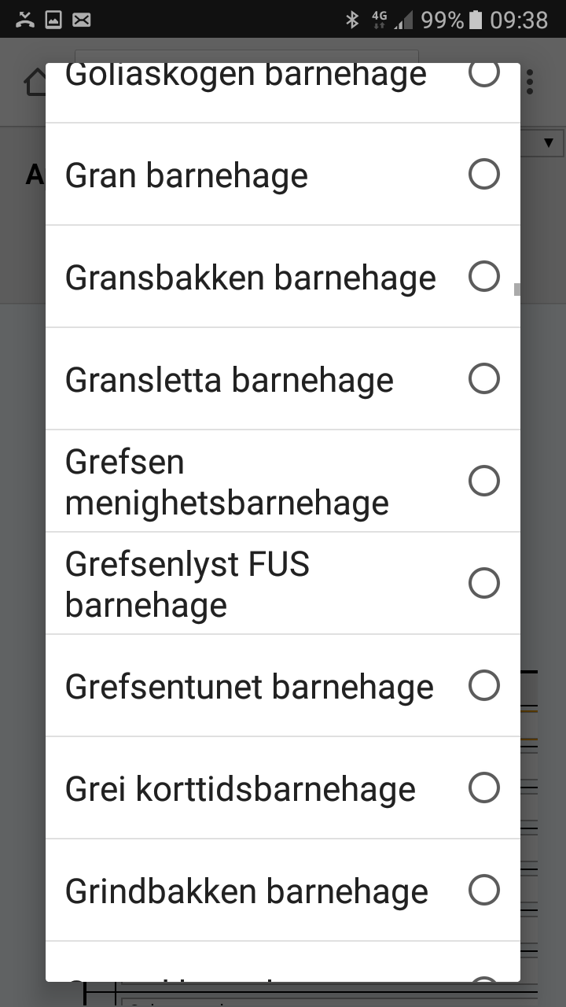

Figure X.1 problematic scrolling menu

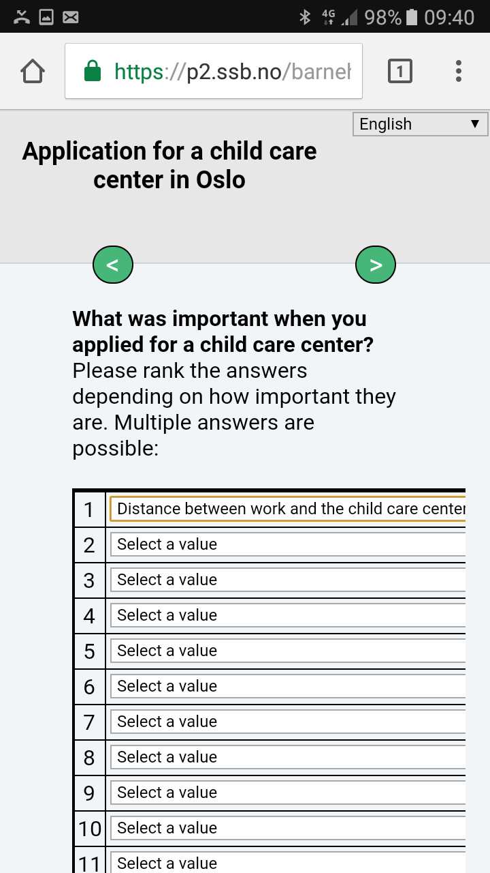

Figure x.2 long drop down menus with small fields

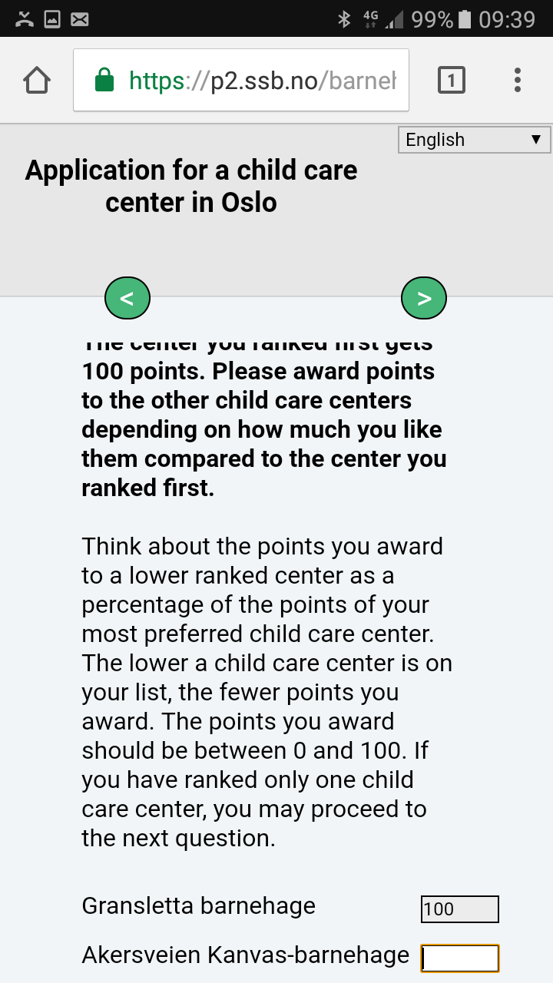

Figure X.3 content and screen appearance mismatch

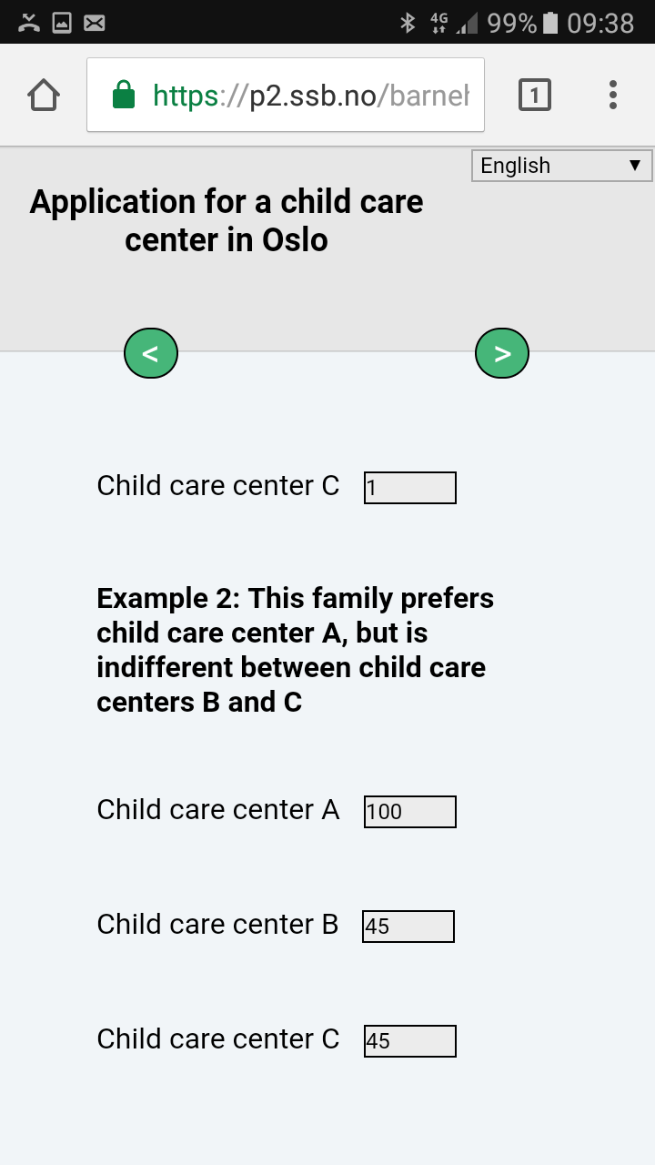

1. Head of division for Social surveys, Department of Digitalization and shared, Statistics Norway
2. Division for Social surveys, Department of Digitalization and shared, Statistics Norway
3. xxx