Interviewer strategies:
influence on contact and cooperation

Communication at the International Workshop on Household Survey Nonresponse
Oslo, September 1, 2016.

Alexandre Pollien¹

¹ FORS – Lausanne University, Geopolis, CH-1015 Lausanne, alexandre.pollien@unil.ch

Abstract
This paper focuses on the strategies of interviewers. It aims to analyse the effect on response of contact strategies. Since 2002, we carried out a face-to-face survey - ESS and MOSAiCH (ISSP) - with the same survey agency, i.e. roughly the same staff of interviewers. A questionnaire about strategies of interviewers was conducted periodically, which nearly two thirds of all interviewers answered. The analysis focuses on factors that contribute to the cooperation of the selected target-person. One of the most important results is that the enthusiasm of the interviewer seems to have no effect. Mentioning that the interview will be “short and nice” appears even sometime counter-productive. Our results show that the interviewers most aware about the difficulty of involving cooperation have the best response rate. On the whole it seems as if the interviewer should not presume what makes the target-person wants to participate. The leverage of decision appears more based on a work of sense-making, than on a self-legitimacy coming from presentation of intrinsic or institutional characteristics of the survey.
Keywords. Interviewer’s strategies, face-to-face surveys, non-response, Switzerland.

Strategies
The base of our investigation is three international face-to-face surveys: ESS, EVS and MOSAiCH (Measures and Sociological Observation of Attitudes in Switzerland, survey including ISSP and questions of Eurobarometer in Switzerland). They are conducted from 2002 onwards by the same research institution in collaboration with the same polling organisation, and with the same standard specifications (ESS are applied to MOSAiCH and EVS). In this paper, we consider the ESS surveys from 2002 to 2014, the MOSAiCH surveys from 2005 to 2015, and the EVS in 2008. The surveys, which alternate each year, are performed under similar conditions by the same team of interviewers, past the unavoidable turnover. Over the years, some changes are introduced gradually. The most important change in our case takes place in 2010. After a period with phone register samples, a brief experiment in 2008-2009 of postal address register was undertaken. Since 2010, the sample frame is drawn from a register of individuals. The latter change transforms also in depth the task of the interview, because it implies to pass from a two-stage selection of respondent process to a one-stage operation. Not only does this save the participation process from a sensitive respondent selection within the household, it also provides us with some characteristics of the respondent in advance (sex, age, full name), supporting the strategies of the interviewer.
Another variation must be identified, especially the implementation and designing of financial incentives. In 2004, the incentive introduced, enabled to increase by 10 points the response rate. Over the years, the incentive system has been improved, from a conditional gift to an unconditional 10 Swiss francs cash system. The interviewer strategy is changed accordingly: when the interviewer comes into play, the incentive has already been given. The effects of the specifications of the procedure are difficult to estimate without experimental plan providing a basis for comparison. Analysis of contacts strategies nevertheless opens an avenue to the understanding of the mechanisms of cooperation. Through the effect of survey design changes, it is possible to observe how interviewers’ strategies affect the contacts process and support the conversion of a target person into a respondent.
This communication aims to analyse the effect of strategies developed by interviewers. Information on strategies is collected using a paper questionnaire distributed to interviewers at the end of each survey fieldwork. Strategies measurements are made using questions about opinion about best practices of contacting and obtaining cooperation. Changes in contact procedures is one of the axes of the analysis. So we can determine relatively precisely the share of the interviewer in the evolution of response rates. A second focus is about the relevance of the interviewer’s strategies: does the declared strategy impact the efficiency? It is however difficult to disentangle the interviewer effect from the whole investigation process. The ability of the interviewer must be distinguished from the sampling scheme and the measurement error. The question of the relationship between quality of interviewer and data quality is not straightforward. Low efficient strategies do not jeopardize necessarily the success of the fieldwork. First, while wrong strategies may discourage forever to cooperate, some disastrous contact may be recoverable; they could even offer a “sympathy pension” to the following interviewer. These analyses of interviewer’s strategies show that we must move beyond a linear perspective of propensity of cooperation. Interviewers faced a wide range of social situations; therefore a set of skills and the ability to use it wisely seems more realist than advocated a single strategy working for everyone in every situation. Thus, one can hypothesize that a plurality of contact strategies fosters to meet a plurality of respondents. The analyses must not only take into account quantitative success of the strategies, but also the ability to recruit all social categories. Regrettably, we do not have the place to address here all these points.
Data
The data were cleared from ineligible or problematic addresses because such issue does not depend on the interviewer, even though it can be assumed that some interviewers are tilted to declare an invalid address or to consider the respondent unable to participate. The outcome reached by the first interviewer assigned can be considered as the effect of the strategies provide by the interviewer to establish contact and get cooperation from the sample unit. By deducting all further contact procedure performed by other interviewer (refusal conversion, telephone call for hard to reach), we intend to measure as much as possible the pure performance of the interviewer. The effort of the interviewer is analysed through a procedural perspective that is to say that we control the impact of each contact attempt.
The data were gathered using a paper questionnaire from 2002 and a web survey since 2013, distributed to interviewers regularly after the fieldwork ended. This questionnaire is not administered by the polling agency and the cooperation is not mandatory, which allows assuming a certain frankness of the response. An identification code can recognize the interviewer’s performance through the various survey waves. Unfortunately, like the shoemaker’s children who sometimes go barefoot, the data are of poor quality, many interviewers do not respond or indicate a false identification code. Hence, there is important data cleaning to do. Some interviewers have taken part almost every wave, others responded only once. Missing data have been supplemented with data from questionnaires filled out before, if they exist, or the following years, otherwise.
We conducted a multilevel analysis with MLwiN software driven by Stata. The MCMC method was used for estimation. We do not distinguish the levels of the interviewer and the survey round (except for analysing careers of interviewers). Thus, the multilevel analysis separates the level of the sample unit and the level of questionnaire (rather than those of interviewer). To simplify the interpretations, we retain only the first interviewer of each contact process. That is to say, we do not take into account the refusal conversion’s phase. We removed information of interviewers with less than 10 addresses assigned.
Results
Between 2002 and 2015, we collected 285 questionnaires from 170 different face-to-face interviewers who visited 39898 addresses in total. The questionnaire’s response rate for “first” interviewer is 41.3% and varies from 0% to 72%.
Table 1: overview of surveys
Surveys | N | Response rate | Sample frame | Incentive
ESS2002 | 1475 | 30.3% | Phone (household) | 10 CHF incond. (stamps)
ESS2004 | 4862 | 41.0% | Phone (household) | 30 CHF condit.
MOSAiCH2005 | 2299 | 41.5% | Phone (household) | 30 CHF condit.
ESS2006 | 3700 | 40.2% | Phone (household) | 30 CHF condit.
MOSAiCH2007 | 2243 | 37.7% | Phone (household) | 30 CHF condit.
EVS2008 | 2967 | 39.4% | Postal (household) | 30 CHF condit.
ESS2008 | 3800 | 39.4% | Postal (household) | 30 CHF condit.
MOSAiCH2009 | 2639 | 38.7% | Postal (household) | 30 CHF condit.
ESS2010 | 2847 | 44.7% | Individual | 30 CHF incond/condit.
MOSAiCH2011 | 2409 | 40.0% | Individual | 30 CHF condit.
ESS2012 | 2904 | 42.7% | Individual | 10/30 CHF incond/condit.
MOSAiCH2013 | 2389 | 45.7% | Individual | 10/20 CHF cash/voucher
ESS2014 | 2940 | 47.3% | Individual | 10 CHF incondit. + gift
MOSAiCH2015 | 2424 | 45.8% | Individual | 10 CHF incondit.+gift

An initial analysis shows that the least efficient interviewers show the lowest participation rate at the interviewer’s study (Table 2). This reflects an important turnover in the first year of the interviewer’s career, even before the completion of the fieldwork: the salary depending on the results, “understandably” stay in the team and respond to our study only interviewers having obtained high cooperation rate in the face-to-face survey. The response rate per interviewer is named “success” in the following.
Table 2: Response rate of interviewer study according to the success in the face to face survey
 | « weak » interviewer |  | « efficient » interviewer
 | < 24% | 24%-33% | 24%-45% | >45% | Total
No questionnaire | 61.6% | 35.3% | 38.4% | 25.4% | 40.4%
Interviewer questionnaire | 38.4% | 64.7% | 61.6% | 74.6% | 59.6%
Total | 100.0% | 100.0% | 100.0% | 100.0% | 100.0%

Another analysis shows that the success depends on the experience of the interviewer. A surprising result is that after a while the rate declines. This has already discussed by Lipps and Pollien (2011). It is as if the most experienced interviewers adjust their strategy to maximize the reward of their efforts: there comes a point of balance where the necessary efforts to obtain new interviews are not cost effective. So there is a trade-off between success and effort that is found after two or three surveys.
Figure 1: saturation of success, “fourth and more” experienced interviewers
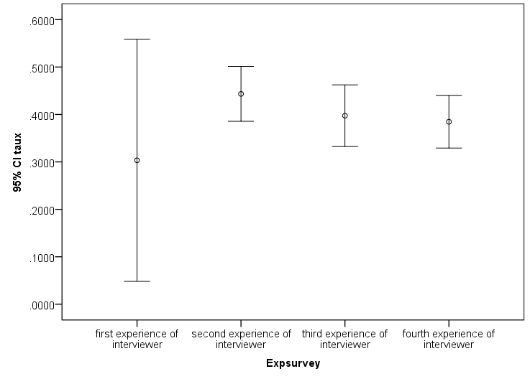
When considering the interviewer effect (Figure 2), it may be noted that the interviewer explains 11% of survey participation. The results of the interviewer effect according to the characteristics of the surveys are difficult to interpret without “ecological” information about the managing of the team of interviewers (hiring, working conditions). But in general lines, we see that the interviewer effect is lower when the selection procedure is of one stage. We also note that the effect increases when the survey institute recruiting new interviewers, as in 2012. We can distinguish three fieldwork eras: from 2002 to 2007, the contact process based on phone register is difficult and poorly effective. The interviewer effect could increase because some interviewers are learning techniques to overcome difficulties induced by contact process constraints. In 2008, the introduction of postal address register comes along with a slight decline of the interviewer effect. The individual sample frame introduced single selection stage in 2010 matches with new decline of interviewer effect. However, this phase is accompanied by a massive recruitment of interviewer from the survey institute.
According to the model II of multilevel analysis (Table 3), we find that age plays a role, as well as experience. In two-stage selection procedure (Table 4, Model IV), women are less effective than men. The grounds could be sociological profile of the interviewers: there are many commercials among men, well versed in sales skills, while female interviewers are often housewives returning to professional life. Education seems to have no effect. Yet, when introducing the strategies’ variables, some of the observed effects remain, indicating that the interviewer effect is as much based on skills than on individual characteristics.

Figure 2: interviewer effect, number of interviewers in fieldwork and response rate according to survey
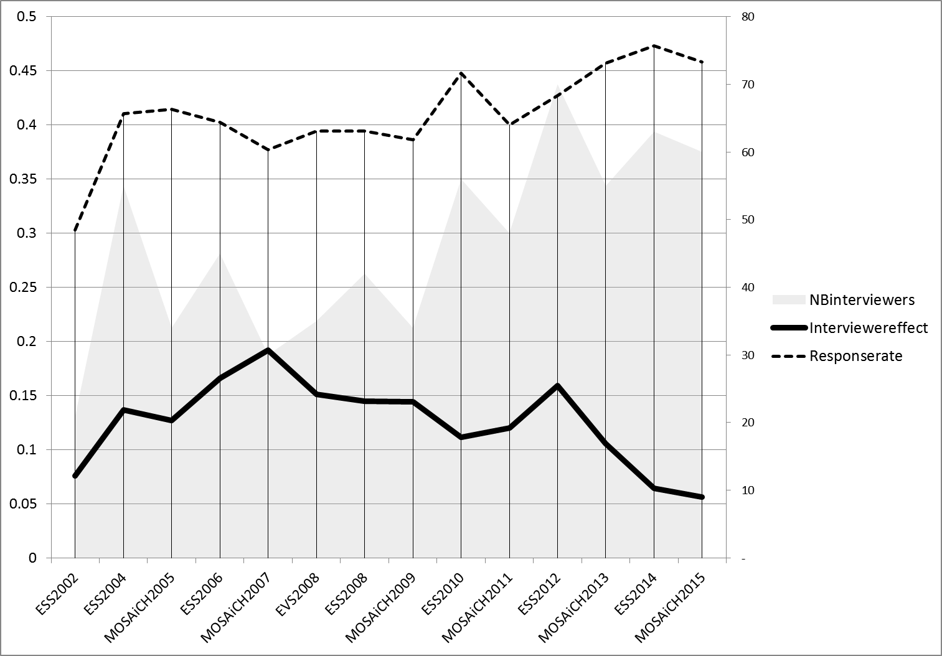

If one looks at the characteristics of the sample unit, results show that location influence the efficiency of each kind of strategies. It was better not to practice in the same way whether the address is located in the city or countryside. Among the general strategies, tailoring seems to be an effective strategy, especially for surveys with selection in two stages. Confidence seems to play a role in fitting an adequacy of the strategy to the characteristics of the target person. Active strategies as looking for information from neighbour are more efficient than promises of utility for the respondent or assertion of interest. If we compare the two-stage selection procedure with the one-stage, we can note that demographic factors are most effective in the two-stage (Model IV), except of education level. Knowing who you are dealing with seems to improve efficiency of women and low education. In the one-stage procedure (Model V), the tailoring strategy seems of less efficiency. However, inferring the respondent will find pleasure has a positive effect on participation. Stressing on incentive seems to no longer apply since the incentive is unconditional and mentioning that the participation is unique has an adverse effect. But in any design, believing that just being at the right time ensures to get cooperation is counterproductive.
Table 3: multilevel analysis, all surveys
 | Interview with the first interviewer: Odds ratio | Model I | Model II | Model III
Level 2: Interviewer | Constant | 0.69 *** | 0.50 *** | 0.61 **
 | Man |  | 1.06 | 1.00
 | More than 50 years old |  | 1.64 *** | 1.50 ***
 | Little experience |  | 1.23 *** | 1.25 ***
 | Lots of experience |  | 0.98 | 0.92
 | Low education |  | 1.10 | 1.15 *
 | High education |  | 0.92 | 0.92
 | Understanding difference |  |  | 1.11 **
 | Asking information to neighbour |  |  | 1.19 ***
 | Mention incentive |  |  | 1.03
 | Usefulness |  |  | 0.90 **
 | Interesting |  |  | 1.12
 | Calling later |  |  | 0.89 *
 | Pleasure |  |  | 0.96
 | Unique respondent |  |  | 0.97
 | Believe in study |  |  | 0.96
 | Right time |  |  | 0.91 **
Level 1: address | City-center |  | 0.84 | 0.81 ***
Random | Residual between-interviewer variation (constant) | 0.42 | 0.41 | 0.35
 | Intraclass variation | 0.11 | 0.11 | 0.10
*p<0.1; **p<0.5 ; ***p<0.01

Table 4: multilevel analysis, household/individual (two/one stages of selection).
 | Interview with the first interviewer: Odds ratio | Model IV | Model V
Level 2: Interviewer | Constant | 0.31 *** | 2.33
 | Man | 1.22 ** | 0.86
 | More than 50 years old | 1.27 ** | 1.27
 | Little experience | 1.31 *** | 1.12
 | Lots of experience | 0.83 *** | 1.02
 | Low education | 1.08 | 1.28 *
 | High education | 0.72 | 0.77 *
 | Understanding difference | 1.23 *** | 1.06
 | Asking information to neighbour | 1.33 *** | 1.10 *
 | Mention incentive | 1.17 *** | 0.89 *
 | Usefulness | 0.84 *** | 0.90 *
 | Interesting | 1.01 | 1.03
 | Calling later | 0.82 *** | 1.05
 | Pleasure | 0.92 | 1.28 **
 | Unique respondent | 1.05 | 0.78 ***
 | Believe in study | 1.09 | 1.03
 | Right time | 0.86 ** | 0.88 **
Level 1: address | City-center | 0.81 *** | 0.86 **
Random | Residual between-interviewer variation (constant) | 0.33 | 0.26
 | Intraclass variation | 0.09 | 0.07
*p<0.1; **p<0.5 ; ***p<0.01
Discussion
To sum up our analysis, we can observe that change of design imply change of strategies. A less efficient design leads to larger adjustment of the most successful interviewers and an increase of interviewer effect. Another result is that the interviewers must convey the need to participate in order to entail the transformation of a hypothetical questionnaire into expectations about interesting moment of daily life. Thus the best strategies need to be of sense-making. A winning strategy is to tailor the presentation for each respondent. But the line is fine between adaptation to the respondents and anticipating their needs: nobody can pretend to know what pleasure or interest can be derived from participating in the interview. Anticipating the wish and interest of the respondent is counter-productive. Prejudging feelings of security, privacy or importance leads to rejection. The confidence is not automatically acquired by the procedure itself, but it must be built through the concrete interaction between the interviewer and the target person. In summary, the solely quality of the survey is not sufficient to make it perceived as worthwhile. The confidence is not granted by the procedure in itself, by showing the sponsor or formal attributes as badge or letter. The solely trust in the quality of the survey is not enough to make it perceived as interesting. Similarly, for the contact, it is not sufficient to arrive at the right time. The needs must be created from an opportunity of contact, a time frame that must be set as time of encounter. Finally, the most important key point of strategy appears to be related to the procedure itself. The legitimacy of participating to an encounter is not self-standing. It is the involvement of the interviewer who gives the indication to the respondent that the interview experience might worth a try. The interviewer must perform a work of conversion. The respondent must find his own way to enter into this particular type of interaction. The interviewer must make the idea that the interview is meaningful and good to be experienced.

References

Lipps O., Pollien A. (2011), Effects of Interviewer Experience on Components of Nonresponse in the European Social Survey. Field Methods 23(2), 156-172.

Let think about the “god cop, bad cop game”.
No more than two years of gap have been completed.
Most of the 0% interviewers giving up prompt.

