Can we use the relationship between income item nonresponse and panel attrition in an adaptive fieldwork design?

A study in the Survey of Health, Ageing and Retirement in Europe (SHARE).

Annette Scherpenzeel, Michael Bergmann, Sabine Friedel, Johanna Bristle.

Working paper for the 27th International Workshop on Household Survey Nonresponse
Wednesday 31 August – Friday 2 September, Oslo, Norway

Introduction
The Survey of Health, Ageing and Retirement in Europe (SHARE) is a multidisciplinary and cross-national panel study of the process of population ageing. Since 2004, data are collected face-to-face every two years, using a harmonized core questionnaire in all countries, as well as objective health measures such as hand grip strength and dried blot spots (Börsch-Supan and Jürges 2005, Börsch-Supan et al. 2013). During the fieldwork of wave six, we monitored several respondent characteristics in relation to response outcomes. Furthermore, we implemented some adaptations of procedures during the fieldwork on the basis of our findings. The lowest response probability we observed was related to income item nonresponse in the previous wave (i.e. wave 5). Respondents who gave no answer to the income question in the previous wave started with a much lower response probability than any other group and mostly remained low. Based on our findings, respondents who did not reveal their income seem to be a group for which responsive measures are especially worthwhile. However, it is difficult to translate this evidence into effective measures during the course of fieldwork or in preparation of a new wave of fieldwork without knowing more about the possible common causes of the income nonresponse in one wave and unit nonresponse in the next wave. Therefore, in preparation for wave 7, we took a closer look at this group.
First, we searched whether other panel studies have found the same relationship between income item nonresponse and panel attrition. Second, we explored the extensive information available in SHARE about the German panel members and about the response process. The results of these two steps are reported in the present working paper. Thirdly, we plan to specifically interview panel members about their reasons for not answering the income questions. The Household Nonresponse Workshop provides a good opportunity to discuss and improve the design of this upcoming part of the study. In the end, the project should result in better adapted strategies for this subgroup, such as different advance letters, specific incentives, or special interviewer instructions, to counteract their higher attrition probability.

Theory
Item nonresponse has been given a lot of attention in the survey methodology literature. In general, three groups of factors affecting the process of (not) answering a question are distinguished: 1) Cognitive factors, such as the effort needed to answer the question and the accessibility of the requested information; 2) Sensitivity of the question or question topic, which can lead to social desirable answering or to privacy concerns; 3) Motivational or attitudinal factors, mostly meant as the general interest in or attitude towards surveys. Some examples of publications describing these factors and item nonresponse answer processes are Beatty and Herrmann (2002), de Leeuw, Hox and Huisman (2003), Tourangeau, Rips, and Rasinski (2000), Stocke (2006), Loosveldt, Pickery and Billiet (2002), Yan and Curtin (2010).
Different theories have been proposed to explain the relationship between item nonresponse and unit nonresponse. Whereas Groves and Couper in 1998 stated that the two types of nonresponse constitute different processes, many recent publications follow the idea of a response continuum as described by Yan and Curtin (2010). Figure 1 is the original depiction of this continuum. Many authors place respondents who do not answer the income questions in the right hand part of this continuum and hence view them as not highly motivated respondents. A few (Serfling, 2005; Taylor, 2006) use instead an economics view of perceived costs and benefits of survey participation and answering income questions. In that view, respondents in the first wave of a panel study do not yet know what the costs of participation are. Those who participate in the first interview can be divided into three groups: 1) respondents who are highly motivated to participate and to give their income; 2) respondents who are at first motivated to participate, feel obliged to answer the income question when it is asked, but perceive it as a burden or intrusion of their privacy; 3) respondents who are generally motivated to participate but do not give their income. In this theory, it is the second group which is most likely to drop out in the next waves. Those who do not give their income do not perceive the income questions as a burden or as costs since they know they will not answer it and participate anyway. This view is the opposite of the response continuum view.

Figure 1. The response continuum model as depicted in figure 1 of Yan and Curtin, 2010.
The response continuum model

Zero propensity Low relative propensity High relative propensity Certain propensity to respond to to respond to to respond to to respond to interview & questions interview & questions interview & questions interview & questions

Other panels in Europe
Several of the ongoing panel studies in Germany and other European countries have published about a relationship between income item nonresponse and panel attrition. Some studies in the German Socio-Economic Panel (SOEP) found a significant relationship (Schräpler, 2004; Frick and Grapka, 2005), whereas one study (Serfling, 2005) did not find a strong relationship, using the 1987 and 1988 SOEP data. Another German panel study, the Panel Analysis of Intimate Relationships and Family dynamics (Pairfam), shows the significant relation between income item nonresponse with respect to household income and participation in the next wave (Müller and Castiglioni, 2015). Loosveldt, Pickery and Billiet (2002) reported strong effects of item nonresponse for the income question during the first interview of the Belgian General Election Study on the unit nonresponse in a second interview. Taylor (2006) reported the same relationship between item non-response and future unit non-response in the English Longitudinal Survey of Ageing (ELSA), a sister-study of SHARE among the same population of people of 50 and older. In the British Household Panel Survey (BHPS), Uhrig (2008) found missing income answers to be highly predictive of subsequent non-response – both due to non-contact and refusal.

Method
The German SHARE sample was generated in 2004 with the help of the municipal registers to obtain a representative probability sample of the population aged 50 years and older. Data are collected face-to-face. Refreshment samples were recruited in wave 2 and wave 5. In the present paper we leave out the refreshment samples from the analyses and focus on the response behavior of the baseline sample of 2004 over panel waves.
Since several types of response rates can be distinguished for longitudinal surveys, it is useful to define in detail which panel response rate we use in this study. Our definition is based on the “conditional cross-sectional” response rate for longitudinal studies, defined by Cheshire et al. (2011) and Lynn (2005) as: The proportion of sample members who respond in a given wave (including partial interviews) of those who responded in the immediately prior wave.
The SHARE questionnaire asks the total household income to one member of each household (the “financial respondent”) as well as a series of detailed income questions, distinguishing different sources of income and pension, to each individual panel member. We use the individual questions for our analysis. “Income missing” is defined as no substantial answer available to any of the following questions: Employment earnings (Ep204), Earnings from self-employment (Ep207), Public pension payments (Ep078), Other regular payments (Ep094). Respondent who were filtered out of all questions (mainly homemakers without any payments) are excluded. A value of 0 € was not set to missing but extreme outliers (>999999 €) in one of the income variables was coded as missing.
The standard individual income questions have not been asked in wave 3, as this wave constituted a retrospective measurement of the life history of the panel members instead of a regular panel wave. Wave 3 is hence excluded from most analyses in this paper. We used the easySHARE dataset in the version from April 2016 for all analyses and tables.

Results

General pattern of income item non-response and attrition across waves.
Our first research question concerned the general pattern of income non-response pattern across waves. Is the income item non-response rate equal in all waves or does it increase or decrease with time? Furthermore, we explored whether a general pattern could be observed of never responding to this question before dropping out completely, or rather a pattern of responding up to a certain wave and then stopping to answer. Figure 2 shows the total number of interviews conducted in the baseline panel sample recruited in 2004, across waves 1,2,4 and 5. In the stacked bars, the total number of interviews is split up into interviews in which income was given and interviews in which income was not given. The latter number of interviews is also shown as percentage of the total number of interviews. In total 2114 of the baseline interviews conducted in the first wave of SHARE Germany included a valid answer to the income questions and 562 (21%) had missing income. The percentage of interviews with missing income steadily decreased over the bi-annual waves of SHARE Germany, to 7% in wave 5. We did not observe a common pattern of consistently not responding to the income questions while remaining in the panel: Only 7 original panel members who still participated in wave 5 had not given their income in any of the waves. Instead, it seems that income non-responders drop out of the panel in an early stage. Figure 3 shows that the response rate in wave 2 was 6 percentage points lower than average for persons who did not give their income in wave 1. In wave 3, the response rate of those who did not give their income in wave 2 was 8.6 percentage points lower than average, and in wave 5 it was 7.5 points lower for those with income item nonresponse in wave 4.

Figure 2. Number of interviews and income item Figure 3. Income item nonresponse and unit
nonresponse across waves nonresponse across waves
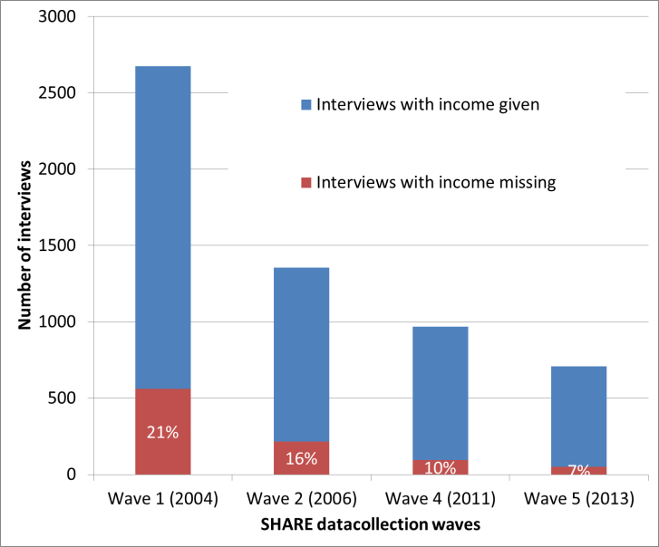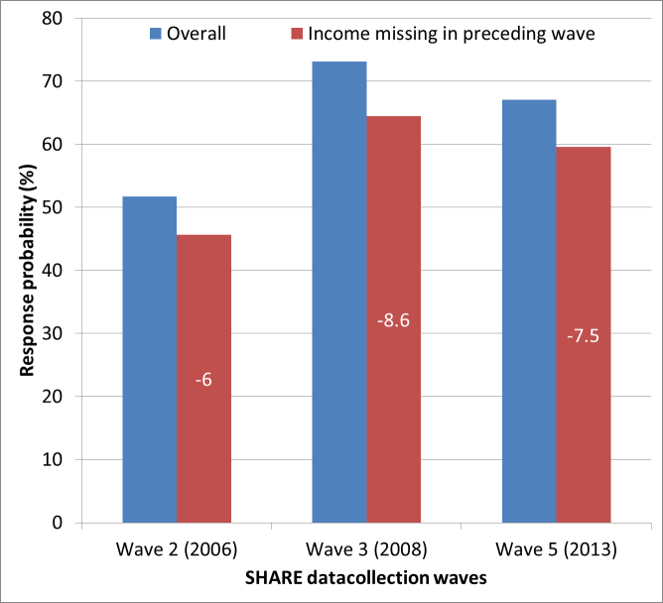

Characteristics of respondents who do not give their income
The large SHARE panel dataset allows to characterize the respondents who do not give their income. Figure 4 shows the distribution of respondents who did and respondents who did not give their income in wave 1, on a number of characteristics. The list of characteristics includes regular demographic variables but also selection of specific SHARE variables such as subjective health, activity level, and scores on cognitive tests. In comparison to respondents who do give their income, those who do not give their income are significantly more likely to still work, have a high income, a somewhat lower verbal memory score, and a higher numerical ability score. In addition, they are less likely to be the SHARE financial respondent in the household. In a second analysis, we compared the characteristics of the drop outs in both subgroups: Compared to respondents who do give their income but drop out after wave 1, those who drop out after not giving their income are higher educated and have lower verbal memory scores (not shown). Since the number of cases in this model is rather low, other effects are not significant even when they are comparable to the effects found in the first model. The full tables of both analyses are given in appendix 1.

Figure 4. Characteristics of respondents who did and who did not give their income in wave 1.
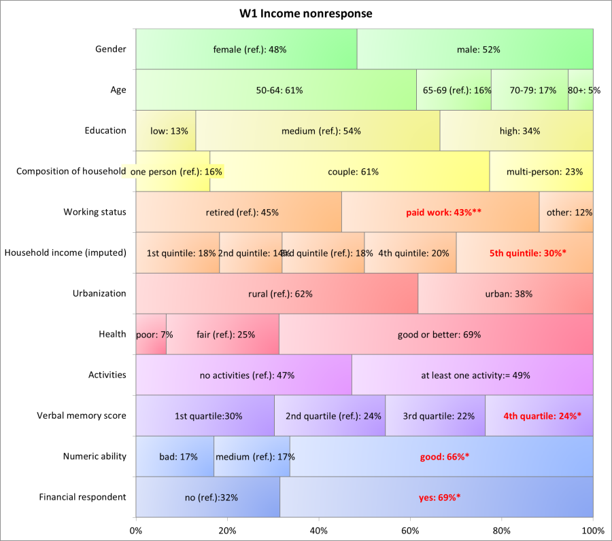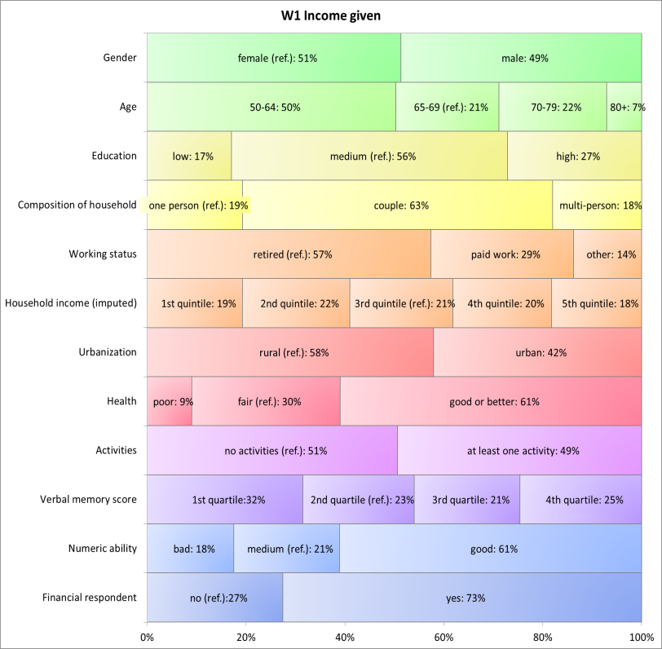

Interviewer effects
We expected the relationship between income item nonresponse and unit nonresponse in the SHARE Germany sub-study to be at least partly causes interviewer effects. With the exception of wave 5 when a change of fieldwork agency took place in SHARE Germany, the same interviewers are assigned to the same respondents over waves whenever possible. As Friedel (2016) describes, SHARE Germany since wave 5 carries out the SHARE Interviewer Survey (cf. Blom and Korbmacher, 2013), which provides detailed information about the interviewers, including their own hypothetical behavior in surveys and their expectations about respondent answers. The interviewer survey is carried out before the interviewers start the fieldwork (for more details about the interviewer survey, see Friedel, 2016, presented at this workshop). Table 1 presents the effect of the interviewer´s own behavior and expectations on the income nonresponse rate obtained from his or her respondents in wave 5. In contrast to the other analyses presented in the paper, this table also includes the refreshment samples of 2006 and 2013, in addition to the baseline sample of 2004. The interviewer survey data are only available for wave 5, at which stage many of the respondents who did not give their income in the baseline panel sample of 2004 have already dropped out. For a proper estimation of the interviewer effects on income nonresponse rates, we therefore included the more recently recruited respondents here as well. The average income nonresponse rate in this total sample was 11%. The results show that interviewers who state they would provide their own income tax assessment to the survey obtain a significantly lower income nonresponse rate from their respondents. Interviewers who expect that most (90% or more) respondents will give their income also obtain a significantly lower income nonresponse rate. However, although the interviewer effects are significant, they in total explain a small percentage of the total variance in income item nonresponse.

Table 1. Effect of interviewer´s answering behavior and expectations on his/her income item nonresponse rate in wave 5. Linear regression, including baseline and refreshment samples.
Income nonresponse rate by interviewer of all Rs in W5 | b
Providing income tax assessment
Very/quite likely |  | -0.04*
Very/quite unlikely (ref.)
Providing debts and loans
Very/quite likely |  | 0.04
Very/quite unlikely (ref.)
Providing social security benefits
Very/quite likely |  | 0.01
Very/quite unlikely (ref.)
High expected % of Rs providing income info |  | -0.06***
Constant |  | 0.13***
Adjusted R² |  | 0.05
Observations |  | 135
* p < 0.05, ** p < 0.01, *** p < 0.001

Conclusion, further research and discussion points
The results of the first stage of our study, which was based on available SHARE data, seem to support more the response continuum hypothesis than the cost-benefit reverse theory. We did not observe a common pattern of consistently not responding to the income questions while remaining in the panel. Instead, it seems that income non-responders drop out of the panel in an early stage. Respondents who do not give their income and drop out are not the oldest old, ill or cognitively challenged sample members. Instead, they are still working, are highly educated and have a high income and good numerical abilities. If they do not answer because they do not know their income exactly this is probably more related to their role in the household than to cognitive limitations. They less often have the role of “financial respondent”, which is likely to be chosen by a household member who manages the household finances. Interviewer effects do play a significant role in the income item nonresponse rate, but can explain only a small part of the variance. In conclusion, the available data have sketched the portrait of respondents who do not give their income and indeed placed them at the right end of the response continuum with regard to motivation and concerns. This does, however, not give enough conclusive information to design an adaptive fieldwork strategy on. Perhaps the best way to find out why income questions are frequently unanswered is to ask a selection of respondents with income item nonresponse themselves. Therefore, we plan a second stage study in which we will carry out CATI interviews in a structure way but allowing open answers, probing, and in depth questioning. The questionnaire should address the different possible causes for income nonresponse: lack of knowledge, sensitivity of the question, general motivation. We propose to include:
- Reasons for participation in the panel (Scherpenzeel and Zandvliet, 2011)
- Survey attitude scale (De Leeuw et al, 2010)
- Perception of survey costs and risks (Couper et al., 2008)
- Privacy concerns (Couper et al. 2008)
- Trust and confidentiality (Couper et al, 2008)
- Hypothetical willingness to answer income question + why / why not
Additional suggestions or different ideas regarding the questionnaire design from the workshop participants are much appreciated.

The main difficulty in the design of this study is the sample selection. We have discussed the following options and would like to discuss them with the workshop participants as well:
1. First, we could ask those SHARE respondents who have not given their income in the upcoming field rehearsal (pretest) of wave 7. As the field rehearsal sample is small, we expect to find only about 45 respondents with income item nonresponse rate in this sample.
2. A second option is to ask SHARE respondents from the main sample who have dropped out from the study and have not given their income in their last wave. The question is how many of the drop-outs are willing to participate in an extra study.
3. Third, we could select and interview SHARE respondents from the main sample who have not given their income in the last wave, without knowing yet whether they will drop out the next wave or not.
4. A completely different option is a fresh sample to be interviewed by telephone and include the actual income question in the interview. We will have to ask a large sample and do some kind of screening to have enough participants over 50 years of age and not willing to give their income.
5. A final possibility is to select a sample from an online panel, including only panel members of 50 years or older who have not given their income, and carry out the interview as a web survey. The assumption then has to be made that an online panel sample is comparable to the SHARE panel sample.
completely different option is a fresh sample to be interviewed by telephone and include the actual income question in the interview. We will have to ask a larger sample or do some kind of screening to have enough participants with income item nonresponse.

References
Beatty, P. & Herrmann, D. (2002). To answer or not to answer: Decision processes related to survey item nonresponse. In: R. M. Groves, D. A. Dillman, J. L. Eltinge & R. J. A. Little (eds.), Survey Nonresponse. New York: John Wiley & Sons.

Blom, A. G. and J. M. Korbmacher (2013): Measuring Interviewer Characteristics Pertinent to Social Surveys: A conceptual framework, in: Survey Methods: Insights from the Field, published on http://surveyinsights.org/?p=817, pp. 1-16.

Börsch-Supan, A. and Jürges, H. (2005). The Survey of Health, Ageing and Retirement in Europe – Methodology. Mannheim: MEA.

Börsch-Supan, A., Brandt, M., Hunkler, C., Kneip, T., Korbmacher, J., Malter, F., Schaan, B., Stuck, S., and Zuber, S. (2013). Data Resource Profile: The Survey of Health, Ageing and Retirement in Europe (SHARE). International Journal of Epidemiology, 42, 992-1001. doi: 10.1093/ije/dyt088.

Cheshire, H., Ofstedal, M. B., Scholes, S., and Schröder, M. 2011. A Comparison of Response Rates in the English Longitudinal Study of Ageing and the Health and Retirement Study. Longitudinal and Life Course Studies, 2.

Couper, M.P., Singer, E., Conrad, F.G. and Groves, R.M. (2008). Risk of Disclosure, Perceptions of Risk, and Concerns about Privacy and Confidentiality as Factors in Survey Participation. Journal of Official Statistics, 24 (2).

De Leeuw, E. D., Hox, J. and Huisman, M. (2003). Prevention and treatment of item nonresponse. Journal of Official Statistics, 19.

De Leeuw, E. D., Hox, J. J., Lugtig, P., Scherpenzeel, C. V., Goritz, A., & Bartsch, S. (2010). Measuring
and Comparing Survey Attitude Among New and Repeat Respondents Cross-Culturally. Wapor annual conference. Chicago, USA.

Frick, J. and Grabka, M. (2005): Item nonresponse on income questions in panel surveys: Incidence, imputation and the impact on inequality and mobility. Allgemeines Statistisches Archiv 89, pp. 49-61.

Friedel, S. (2016). Item nonresponse and interviewer effects on asset questions in SHARE. Paper to be presented at the 27th International Workshop on Household Survey Nonresponse, Oslo, Norway.

Groves, R.M. and M. Couper (1998). Nonresponse in Household Interview Surveys, Wiley, New York.

Jörg-Peter Schräpler (2004): Respondent Behavior in Panel Studies. A Case Study for Income onresponse by Means of the German Socio-Economic Panel (SOEP). Sociological Methods & Research 33(1), pp. 118-156.

Loosveldt,G., Pickery, J. and Billiet, J. (2002). Item nonresponse as a predictor of unit nonresponse in a panel survey. Journal of Official Statistics, 18 (4).

Lynn, P. 2005. Outcome Categories and Definitions of Response Rates for Panel Surveys and Other Surveys Involving Multiple Data Collection Events from the Same Units. 16th International Workshop on Household Survey Nonresponse.

Müller, B. and Castiglioni, L. (2015): Attrition im Beziehungs- und Familienpanel pairfam, in: Schupp/Wolf (Eds.). Nonresponse Bias. Wiesbaden: Springer.

Scherpenzeel, A. and Zandvliet, R. (2011). Slapers en inactieven binnen online panels. In: Ontwikkelingen in het marktonderzoek: Jaarboek MarktOnderzoekAssociatie, 36, 189-204. Spaar^{en} Hout Haarlem.

Serfling, O. (2205). The Interaction between Item, Questionnaire and Unit Nonresponse in the German SOEP. In: Schmollers Jahrbuch 125, Duncker &Humblot, Berlin.

Stocké, V. (2006). Attitudes toward Surveys, Attitude Accessibility and the Effect on Respondents’ Susceptibility to Nonresponse. Quality & Quantity, 40.

Taylor, R. (2006). Using item non-response to predict future unit-nonresponse: ELSA as a case study. MOLS 2006 conference paper.

Tourangeau, R., Rips, L.J., and Rasinski, K. (2000). The Psychology of Survey Response.
Cambridge: Cambridge University Press.

Uhrig, SC N. (2008). The nature and causes of attrition in the British Household Panel Survey. ISER Working Paper 2008-05.

Yan, T. and Curtin, R. (2010). The Relation Between Unit Nonresponse and Item Nonresponse: A Response Continuum Perspective. International Journal of Public Opinion Research, 22 (4).

Appendix 1.

Table 1. Characteristics of respondents who did (not) give their income in wave 1
 | w1 income given |  | w1 income nonresponse
 | N | Observed % | N | Observed % | b
Gender
female (ref.) | 1085 | 51.3 | 272 | 48.4
male | 1029 | 48.7 | 290 | 51.6 | 0.05
Age
50-64 | 1040 | 50.3 | 338 | 61.3 | 0.00
65-69 (ref.) | 430 | 20.8 | 90 | 16.3
70-79 | 450 | 21.8 | 93 | 16.9 | 0.00
80+ | 146 | 7.1 | 30 | 5.4 | -0.02
Education
low | 359 | 17.0 | 73 | 13.1 | -0.06
medium (ref.) | 1176 | 55.8 | 299 | 53.5
high | 572 | 27.1 | 187 | 33.5 | 0.16
Composition of household
one person hh (ref.) | 407 | 19.3 | 91 | 16.2
couple hh | 1326 | 62.7 | 344 | 61.2 | -0.07
multi-person hh | 381 | 18.0 | 127 | 22.6 | 0.08
Working status
retired (ref.) | 1213 | 57.4 | 252 | 45.0
paid work | 610 | 28.9 | 242 | 43.2 | 0.44**
other | 291 | 13.8 | 66 | 11.8 | 0.12
Household income (imputed)
1st quintile | 408 | 19.3 | 103 | 18.3 | 0.13
2nd quintile | 458 | 21.7 | 77 | 13.7 | -0.32
3rd quintile (ref.) | 442 | 20.9 | 101 | 18.0
4th quintile | 422 | 20.0 | 113 | 20.1 | 0.05
5th quintile | 384 | 18.2 | 168 | 29.9 | 0.37*
Urbanization
rural (ref.) | 1211 | 57.9 | 340 | 61.7
urban | 880 | 42.1 | 211 | 38.3 | -0.16
Health
poor | 191 | 9.0 | 37 | 6.6 | -0.06
fair (ref.) | 635 | 30.0 | 139 | 24.7
good or better | 1288 | 60.9 | 386 | 68.7 | 0.21
Activities
no activities (ref.) | 1062 | 50.6 | 263 | 47.2
at least one activity | 1035 | 49.4 | 294 | 52.8 | 0.02
Verbal memory score
1st quartile | 653 | 31.5 | 168 | 30.3 | 0.07
2nd quartile (ref.) | 467 | 22.5 | 135 | 24.3
3rd quartile | 443 | 21.4 | 121 | 21.8 | -0.24
4th quartile | 511 | 24.6 | 131 | 23.6 | -0.35*
Numeric ability
bad | 369 | 17.5 | 96 | 17.1 | 0.30
medium (ref.) | 450 | 21.4 | 93 | 16.6
good | 1287 | 61.1 | 372 | 66.3 | 0.30*
Financial respondent
no (ref.) | 579 | 27.4 | 177 | 31.5
yes | 1535 | 72.6 | 385 | 68.5 | -0.25*
Constant |  |  |  |  | -1.63***
McKelvey and Zavoina's R² |  |  |  |  | 0.06
N (multivariate model) |  |  |  |  | 2521
* p < 0.05, ** p < 0.01, *** p < 0.001

Table 2 Characteristics of respondents who did (not) give their income in wave 1 and dropped out after wave 1
 | w1 income given, drop-out after w1 |  | w1 income nonresponse,  drop-out after w1
 | N | Observed % | N | Observed % | b
Gender
female (ref.) | 441 | 51.9 | 132 | 49.4
male | 408 | 48.1 | 135 | 50.6 | -0.04
Age
50-64 | 372 | 45.4 | 149 | 57.1 | 0.06
65-69 (ref.) | 171 | 20.9 | 46 | 17.6
70-79 | 197 | 24.0 | 47 | 18.0 | -0.07
80+ | 80 | 9.8 | 19 | 7.3 | -0.14
Education
low | 158 | 18.6 | 33 | 12.4 | -0.29
medium (ref.) | 492 | 58.0 | 146 | 54.7
high | 199 | 23.4 | 88 | 33.0 | 0.42*
Composition of household
one person hh (ref.) | 197 | 23.2 | 51 | 19.1
couple hh | 512 | 60.3 | 156 | 58.4 | -0.12
multi-person hh | 140 | 16.5 | 60 | 22.5 | 0.23
Working status
retired (ref.) | 500 | 58.9 | 131 | 49.2
paid work | 236 | 27.8 | 104 | 39.1 | 0.27
other | 113 | 13.3 | 31 | 11.7 | -0.05
Household income (imputed)
1st quintile | 204 | 24.0 | 62 | 23.2 | 0.18
2nd quintile | 178 | 21.0 | 32 | 12.0 | -0.36
3rd quintile (ref.) | 152 | 17.9 | 44 | 16.5
4th quintile | 173 | 20.4 | 60 | 22.5 | 0.22
5th quintile | 142 | 16.7 | 69 | 25.8 | 0.30
Urbanization
rural (ref.) | 415 | 49.6 | 138 | 53.3
urban | 422 | 50.4 | 121 | 46.7 | -0.17
Health
poor | 89 | 10.5 | 17 | 6.4 | -0.30
fair (ref.) | 266 | 31.3 | 77 | 28.8
good or better | 494 | 58.2 | 173 | 64.8 | 0.06
Activities
no activities (ref.) | 485 | 58.0 | 128 | 48.7
at least one activity | 351 | 42.0 | 135 | 51.3 | 0.21
Verbal memory score
1st quartile | 282 | 34.5 | 80 | 30.7 | -0.17
2nd quartile (ref.) | 164 | 20.1 | 67 | 25.7
3rd quartile | 167 | 20.4 | 52 | 19.9 | -0.50*
4th quartile | 204 | 25.0 | 62 | 23.8 | -0.61**
Numeric ability
bad | 170 | 20.1 | 52 | 19.5 | 0.49
medium (ref.) | 181 | 21.4 | 44 | 16.5
good | 495 | 58.5 | 170 | 63.9 | 0.32
Financial respondent
no (ref.) | 227 | 26.7 | 81 | 30.3
yes | 622 | 73.3 | 186 | 69.7 | -0.25
Constant |  |  |  |  | -1.18**
McKelvey and Zavoina's R² |  |  |  |  | 0.08
N (multivariate model) |  |  |  |  | 1021
* p < 0.05, ** p < 0.01, *** p < 0.001

EasySHARE release 2.0.0 , doi 10.6103/SHARE.easy.200. An updated version of easySHARE has recently been released, which was not yet used for this paper.
Wave 3 is left out because this was a special wave about life histories, in which the present income was not asked.
To test for significance, a logistic regression model was ran including all respondent characteristics as explanatory variables and income item nonresponse as dependent variable (0=income response, 1= income nonresponse). As we are interested in the raw distribution of respondents answering the income questions or not, no specific weights have been applied.
The variable “financial respondent” indicates whether the respondent is assigned the role of giving the household level finances and assets (this is done by only one respondent per household).
For the 2013 refreshment sample, wave 5 was their first wave.

