Territory of interviewer in face-to-face surveys
Virtual Nonresponse Workshop, August 26, 2020.
Alexandre Pollien and Jean-Marie Le Goff
Disentangle effects
Studies of interviewer variability in data collection date from the 1940s (Mahalanobis, 1946). Since then interview instrument has received a sustained interest, identifying interviewers as an important source of error in data collected from face-to-face interviews (Groves and Kahn 1979). Survey statisticians consider that the interviewer effect arises from positive covariance between the response deviations. Studies that attempt to establish the extent of variance attributable to the interviewer assume that the allocation of sampling units is comparable in terms of variables related to the propensity to participate. However, the standard for face-to-face interview surveys is to have the workload from a given area assigned to a single interviewer and, moreover, to have each interviewer working in only one area. Sample units assigned to interviewers add non-sampling variance as sociologically there are positive correlations between people living in the same area. Separate the interviewer effect from the area effect can be achieved in an interpenetrated design where sampled units are randomly assigned to interviewers (West, 2017). In typical face-to-face surveys, field requirements, travel costs and interviewers’ working schedules never allow for such design: interviewers are necessarily assigned to geographic regions. To disentangle the variance due to the interviewer from the variance due to the geographical embedment, researchers have implemented partially interpenetrated designs, where adjacent areas are pooled and at least two interviewers are randomly assigned to sample units in each of those areas (O’Muircheartaigh and Campanelli 1998). The interpenetrated design is implemented through a constrained form of randomisation in which addresses were allocated to interviewers at random within geographic “pools”.
In partially interpenetrated designs, the models include crossed random effects of interviewers and areas. If there is evidence of variability among interviewers in respondent characteristics despite random assignment (West and Olson 2010), researchers need to carefully specify multilevel models that include the fixed effects of both area and respondent characteristics. In general, analyses that attempt to extract strategy variables from environment variables fail to fully separate the variances. First, technically, the random effect of interviewers and areas is estimated with substantial error because of small numbers (O’Muircheartaigh and Campanelli 1999). Second, it is not assured that the variables determining the area and thus controlling for random assignment are key variables from the point of view of interviewer strategies. A partial interpenetrated design only makes it possible to measure the variance in relation to another assignment. The overall point is that interviewer effect is conceptualised in regard to selection effect resulting from interviewer strategies. Looking at interviewer effect as a result of strategies, i.e. as a result of competencies issued from training and learning practises in the field, suggests a third argument: the strategies performed are intrinsic to the area assigned to the interviewer. This approach is sustained using the concept of territory borrowed from Gilles Deleuze and Felix Guattari.
Territory of Interviewer
The environment of the interviewers is seen as a territory in the sense of an area over which competencies are drilled. The concept of territory allows assessing for structural function of elements in the collect of survey data. The interviewers are associated with their work area in a pragmatic approach where the configurations are seen as challenges on their own. And it also theoretically makes it possible to overcome the critics of Deleuze which, in our case, would consist in analysing about the properties of the interviewers regardless of where they operate. The interviewer develops an identity, strategies and field achievements concomitantly, in a process called territorialisation. According to Deleuze, human as animal territorializes through a series of markings, signs, postures, gestures, and sounds. In that respect, the competencies define the territory: The territory is where the interviewer achieves contacts and co-operation from sample units. The set of habits forming the competencies of interviewer have no efficiency outside the territory, the gestures are unsuccessful and unintelligible. The behaviour works because its meaning is defined within the territory. The concept of territory thus makes it possible to define in the articulation of the area and the interviewer strategies, it is linked to the propensity to achieve contacts and obtain co-operation.

Experience based on job as interviewer
Area
Geographical skills
Sociological skills
Territory
Methodological decisions and guidelines based on results
Training
Survey design
Strategies
Competencies
Psychological skills

While the relation between the strategies and their influence in the data collection process is fairly documented (West, 2017), the structure informing these strategies, which can be summed up by the concept of competency has been addressed to a smaller degree. The competency is issued from ongoing experience of the field and from training. Researchers establish a relation between the selection of valid addresses and the interviewer’s experience (SAMHSA, 2008). Qualifying invalid addresses may constitute a last resort solution in case of hard-to-reach or unclear addresses (Eckman and O’Muircheartaigh, 2011, Tourangeau, Kreuter and Eckman, 2012). Differences regarding the definition and imputation of eligibility are linked to geographical skills: address not traceable, misdirection, wrong entry door, are the result of a spatial experience of the field.
Research has emphasised the importance of the moment of contact. Interviewers use social information to decide when to contact. Interviewers with more experience in a given survey use more effective strategies to establish contact: interviewers use of social competence in refining when to call as non-contact occurs (Purdon, Campanelli et Sturgis, 1999). Interviewers develop naive social theories about accessibility of respondents depending on their employment and occupational status. Another aspect to take into account is that people refuse to answer their doors after dark or do not like to be disturbed when they are with their family, eating or looking after their children. The sociological right time to contact - the Greek notion of Kairos – interacts with the geographical strategy. Since it is impossible to visit all addresses at the same time, roadmap strategies are aimed to concerns including maximising the chances of contact and co-operation according to the distances between each address and their respective Kairos. These skills rely on the practical knowledge of access and communication routes. Several authors find a correlation between success in contact and success in co-operation (O’Muircheartaigh and Campanelli 1999; Pickery and Loosveldt 2002; Blom et al. 2011; Durrant and D’Arrigo 2014). Contacting and obtaining co-operation are two related dimensions that can be summed up by the concept of social accessibility. When the contact is hard to achieve, it is very likely that the work of persuasion will also be very challenging: the windows of co-operation is narrow. The relationship between these two variables is realised psychologically (encounter is rare which makes it “costly”) or sociologically (privacy is protected both by physical barriers as entry phone, locked gate, and by reluctant attitude). The ability to plan the best time to visit the households needs an informal knowledge of the sociological profile of neighbourhoods, understanding time use and physical access in order to open up social accessibility as much as possible.
Many studies highlight the relation between interviewer’s experience and co-operation. Jäckle and colleagues note that more experienced interviewers have a larger repertoire of arguments and persuasion techniques, making them better able to tailor their approaches (Jäckle, Lynn, Sinibaldi and Tipping, 2013). Social skill as knowing and applying rules of accepted behaviour and communication plays a role (Hox and de Leeuw, 2002). The behaviour thought to be the key to obtaining co-operation is the ability to adapt the survey request to the respondent's motivations (Lemay and Durand, 2002), and to maintain the interaction for long enough in order to identify about his or her concerns (Groves and Couper, 1998). In the interviewer's perspective, co-operation strategy consists of tailoring behaviour to the target population of the area, sociologically defined. Due to their geographical location, the samples of address assigned to interviewer are quite homogeneous from the point of view of sociological profiles, local habits and rituals, making each area unique, as a territory to gather.
Lemay and Durand found that interviewers rarely use the arguments of the interview script to convince respondents (Lemay and Durand 2002). This observation suggests a gap between the formal guideline of the survey and the actual work of the interviewers. Interviewers adapt their tasks to fit them with their own conception of the work which is not of scientifically measuring attitudes but of requesting co-operation and doing interviews using common and local know-how. Based on past and anticipated social experiences, the interviewers’ strategies are fundamentally procedural. The work of contact and persuasion use competencies in order to optimise efforts, travel time and arrive at the best time to contact the respondent. Thus the contacts process, including the pace of contacts attempts and the changing learning strategies of persuasion is the core of survey participation process. These observations support the need to consider interviewers’ strategies as an activity of territorialisation that never succeed in gaining the whole area assigned: from the survey scientist’s point of view, it results in a non-response rate; from the interviewer's point of view, it results in a degree of acquaintance with regard to the sociological area and the geographical space assigned.
Clusters of Interviewers
Considering our hypothesis of a temporal dimension, interviewer strategies are analysed through a typology of arrangements of non-contacts, refusals or responses during the contact process. Based on sequences of contact attempts, this typology can be viewed as a measure of performance. The paradata are taken from the European Social Survey (ESS) and MOSAiCH (ISSP) surveys made in Switzerland between 2010 and 2015. The standard procedure requires that after a refusal or five unsuccessful contact attempts, the conversion phase takes place along with another interviewer. In order to simplify the measurement of the interviewer’s performance, only the first five contact attempts of the first interviewer assigned to the address is included in the analysis. Matrix Population Models are used in demography to make population projections with mortality, fertility and migration. In our model, we retain four different outcomes: interview, refusal, no contact and other. The series of probabilities of co-operation, refusals and others are computed, introduced in a population matrix. The matrix of probabilities is analysed with a clustering computation. We used Agnes with the Ward method, which indicated that a three-cluster solution was fine. Then, Kmean method allows ordering a partition into three classes to consolidate the classification. Results confirm that clusters are mainly structured by the pace of the contact process.
Type 1: Pernickety (n = 86, RR= 46.1%)  The first type of cluster is consisting of slower interviewers in the contact process but with a progressive increase in co-operation. It looks that interviewers scrupulously following instructions. They seem somewhat pointy, procedural. |  |  |  | 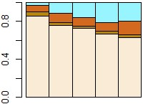
Type 2: rushed (n = 79, RR = 39.6%)  The second type includes interviewers with shorter and more chaotic sequences of contacts. The contact process is short with some protocol failures. There is a medium but declining co-operation. The “rushed” type is significantly associated with less experienced interviewers. |  |  |  | 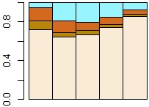
Type 3: pragmatic (n = 51, RR = 55.3%)  The third type includes interviewers succeeding earlier to get contact. The co-operation rate increases progressively. The interviewers in this cluster achieve less non-contact, more interviews. They show some heterodoxy in behaviour. The “pragmatic” type is significantly associated with experienced interviewers and rural areas. |  |  |  | 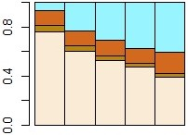
 |  | Interview | Refusal | Other | No contact

The typology shows no significant differences in gender, age. Whereas the distribution of clusters by address assignment show differences in terms of the type of urbanity, we found no differences in geographical distribution by regions or spoken languages. The strategies seem to be more related to the accessibility and lifestyle of respondent than to cultural differences. This supports the hypothesis that strategies are an adaptation to the field constraints.
Avowed Interviewer Behaviours
Measures of attitudes related to interviewers’ strategies are based on data collected with a self-administered questionnaire adapted from the International Interviewer Questionnaire (Hox and de Leuw, 2002, de Leuw and Hox 2009). Filled after each fieldwork ends, the questionnaire includes items on attitudes about strategies of contact and persuasion. We tested our clusters of performance of interviewers with the attitudes expressed with a factor analysis of correspondences. The mapping of the correspondence analysis uses the response from the interviewer questionnaire. The clusters, contact outcome, contact indicators and sociodemographic are taken from the contact data and the sample register. They are included as additional variables. This analysis shows that interviewer profiles based on performance are related to strategies expressed in the interviewers’ questionnaire. The three clusters are linked to interviewers’ role, avowed interviewer behaviours and also achievements in contact and persuasion tasks.
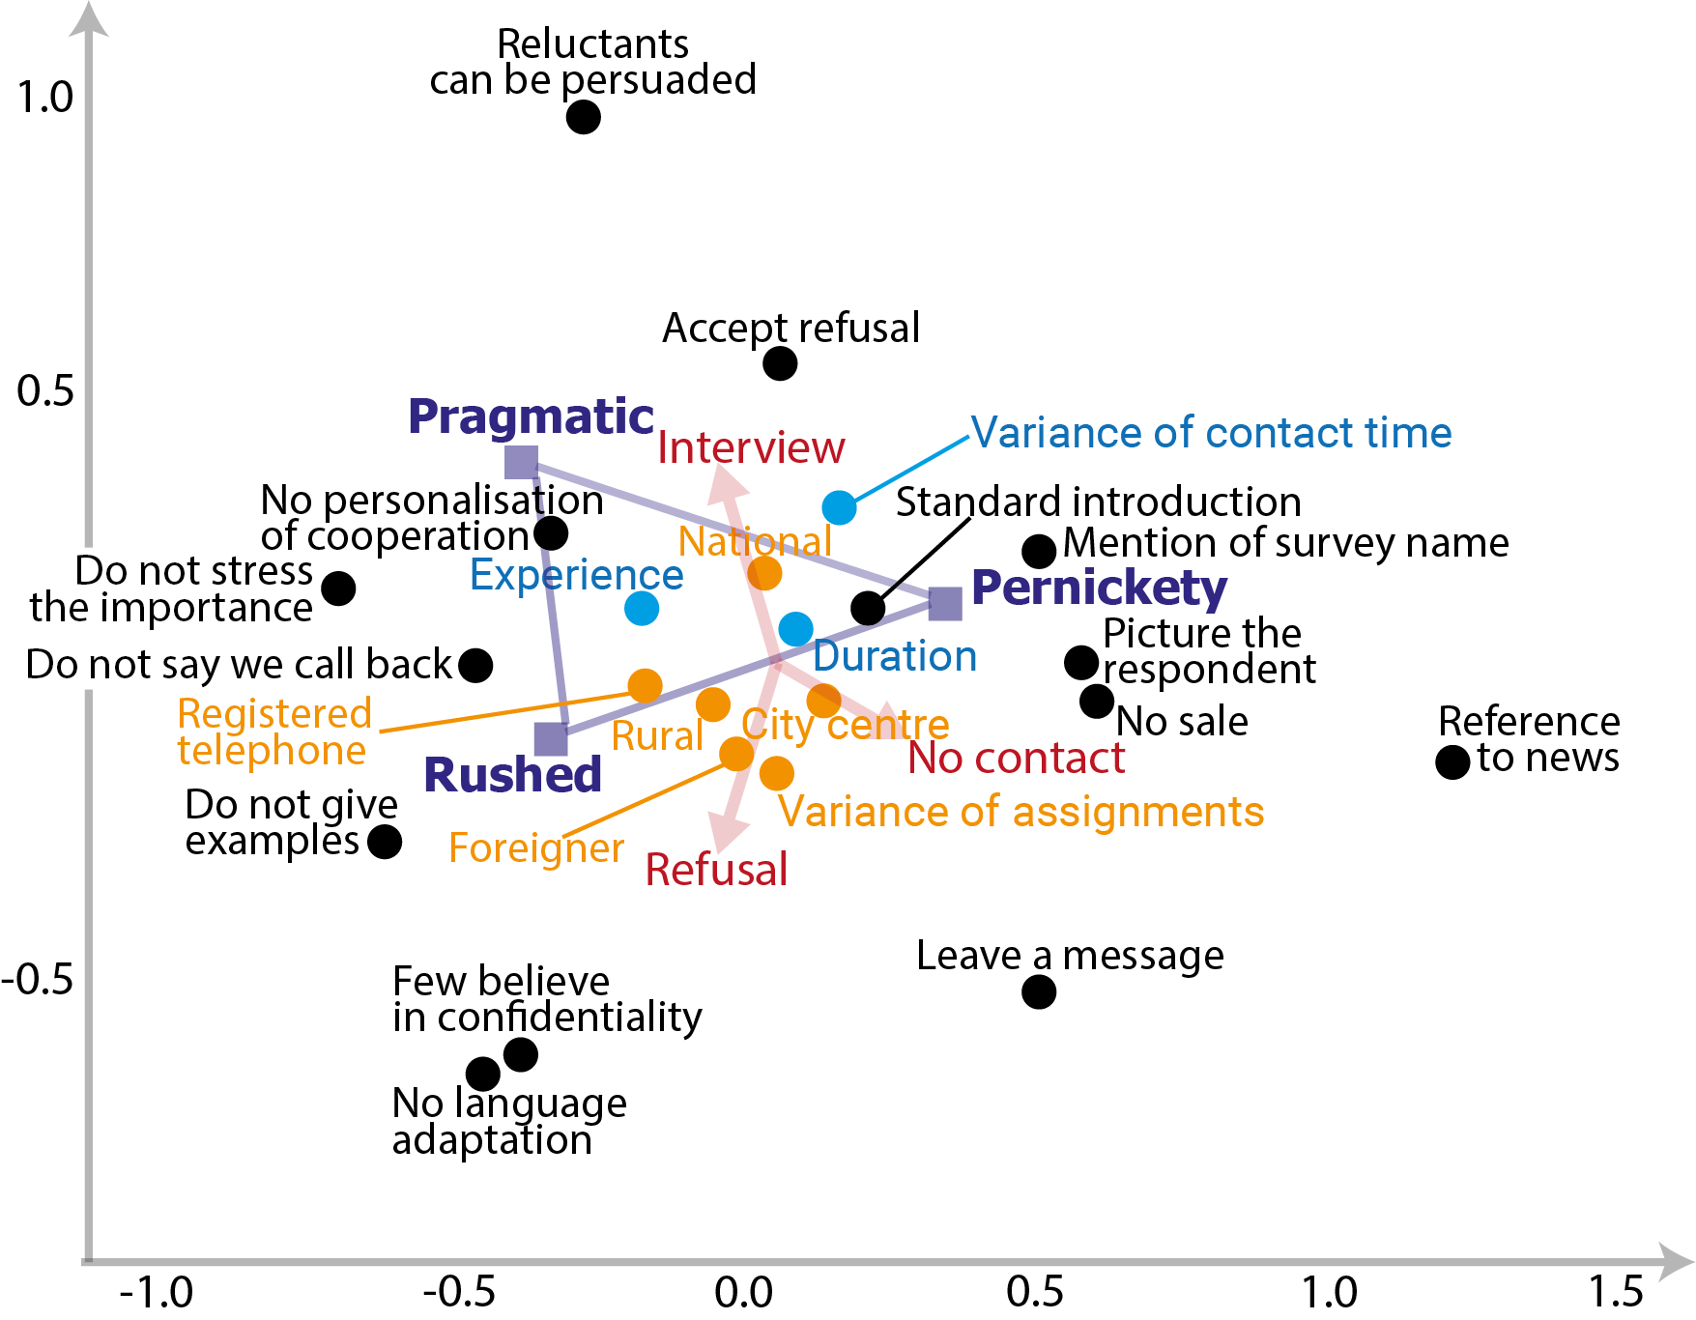
At the top right, we observe some fairly academic strategies. After the standard introduction interviewers of this type systematically present the survey, specify that they do not sell anything and refer to elements of the questionnaire related to media news. Appropriately to the stereotypical advice given to interviewers, they try to picture the respondent. This interviewer model appears to be what we define as a pernickety style, which, however, does not achieve exceptionally high response rate. At the bottom, there is a kind of idealism expressed with the belief that leaving a message could do the job. It seems that this type of strategy leads to more non-contact: in city centres, the most of the interviewer job consists of staying behind an enclosed building door. The left sector of the map shows more realistic attitudes. The interviewers work quickly and do not systematically follow the instructions raised in training as giving simple examples, explaining the importance of the survey. At the bottom right, attitudes looking as a kind of cynicism: respondents would not be convinced by the confidentiality promises. Interviewers do not necessarily try to adapt to the respondent. This configuration of strategy leads to significantly more refusals. Finally, the top left quadrant shows a tailoring bounded by a balanced realism: a certain amount of work of persuading need to be carried out but in the other side the refusal must be accepted. Each actor takes one’s role: the interviewers don’t personalise co-operation with arguments as "you would help us by participating”.
Analysis of the interviewer’s territory
Finally, we measured the interviewer's territory, conceptualised as the propensity to obtain interviews according to different dimensions available in the sample or in the environment questionnaire (i.e. also for non-respondents). The odds ratio is computed per interviewer and a cluster mean is calculated for each cluster. We code as missing all the cells containing fewer than 5 cases, in order to avoid extreme values: for each category, each interviewer had at least 5 respondents and 5 non-respondents.
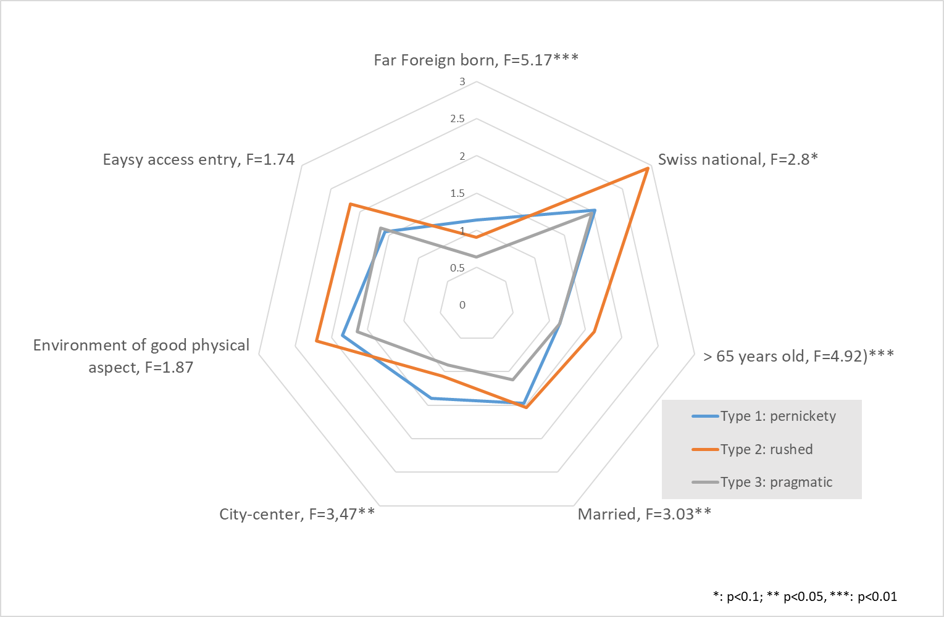
The results should be considered with caution, given the relatively low numbers (we have favoured a stable odds ratio over the number of cases). They show low significant differences. Nevertheless, we find that the results make sense. It should be noted that there is a selection of interviewers that are not too failing in their job, so the differences between interviewers are subdued. The rushed strategies produce significant biases by picking “low hanging fruits”: easily accessible entry doors (without any entry code nor interphone), Swiss citizens, elderly. Pragmatic strategies seem not to invest too much effort in respondents deemed reluctant (far foreign-born). Finally, the pernickety, who have overall fairly lower response rates seems to show less biased samples of final respondents.
These analyses need to be refined in several directions. First of all, we need to analyse a few more variables. We have noticed that the cluster is related to age: the career of the interviewers must also be scrutinised. Our analyses should be improved with other more adequate methods. Beyond our data, more cases should be found or the method should be tested on other survey institutes and surveys. But the study of face-to-face interviewers, because of their actual implementation, will never easily fulfil the assumptions of quantitative analysis: they will always be few in number and assigned in incomparable working conditions. Our approach is observational and should be further strengthened by observing the work of interviewers in situ according to the hypotheses identified, collecting more variables to describe as fully as possible these ideal types. Finally, the use of these ideal types during the training of interviewers, in an approach that would become "participatory action research", can feed this approach.

References
Casweel H. (2001). Matrix Population Models. Construction, Analysis and Interpretation. Sunderland: Sinauer Associates.
Deleuze Gilles and Felix Guattari (1987). A Thousand Plateaus, University of Minnesota.
Hox, J. J., and E. D. de Leeuw (2002), “The Influence of Interviewers’ Attitude and Behavior on Household Survey Nonresponse: An International Comparison,” in Survey Nonresponse, eds. R. M. Groves, D. A. Dillman, J. L. Eltinge, and R. J. A. Little, pp. 103–120, New York: Wiley.
Jäckle, A., P. Lynn, J. Sinibaldi, and S. Tipping (2013), “The Effect of Interviewer Experience, Attitudes, Personality and Skills on Respondent Co-operation with Face-to-Face Surveys,” Survey Research Methods, 7, 1–15.
Lemay, M., and C. Durand (2002), “The Effect of Interviewer Attitude on Survey Co-operation,” Bulletin De Methodologie Sociologique, 76, 27–44.
O’Muircheartaigh, C., and P. Campanelli (1998), “The Relative Impact of Interviewer Effects and Sample Design Effects on Survey Precision,” Journal of the Royal Statistical Society: Series A, 161, 63–77.
West Brady T. and Annelies G. Blom (2017) Explaining Interviewer Effects: A Research Synthesis, Journal of Survey Statistics and Methodology, Volume 5, Issue 2, Pages 175–211.

FORS, Swiss Centre for Expertise in Social Sciences, University of Lausanne. alexandre.pollien@fors.unil.ch
Life Course and Inequalities Research Center, University of Lausanne & NCCR LIVEs, Lausanne. jean-marie.legoff@unil.ch

