Paper prepared by Helen Moore, Jen Farnall and Jo Taylor (Office for National Statistics) 30th International Workshop on Household Survey Nonresponse, 25-28th August 2020.
A Response Rate Strategy for the UK Office for National Statistics
Background
- Outputs from household surveys conducted by the Office for National Statistics (ONS) underpin core UK National Statistics and the wider statistical system. ONS’s vision is to transform its data collection by using new technologies and non-survey data to improve quality, efficiency and better meet user needs.
- Household surveys will continue to play an important part in the current and future data collection landscape. Response rate continues to be the single value most often used to measure their success, with users of survey outputs associating response rates with the confidence they have in the data. There is a long-running general downward trend in social survey response rates for the ONS and other UK and international survey organisations.
- The ONS Social Survey Response Rate Strategy was developed in 2018 to deliver performance and quality improvements to address the concerns of ONS’s National Statistics Executive Group (NSEG) and its key stakeholders about response rates, particularly in relation to the largest ONS household study, the Labour Force Survey (LFS). It brought together existing initiatives, maturing activities, continuous improvement and transformation priorities. It covered the period April 2018 to March 2021, with longer term activities associated with the transition to transformed household surveys extending to March 2024.
- The strategy recognised that, to achieve success in the present environment, a more holistic approach needed to be adopted than had previously been the case. ONS has a large field interviewing community of over 1,000 permanently employed staff. The respondent environment for conducting household surveys is becoming increasingly difficult. We are part-way through a transformation programme that aims to introduce online and mixed-mode surveys and which brings with it new technologies and major changes to working practices.
- The strategy therefore aims to develop a survey operation of the highest capability which will deliver the results we need in an increasingly tough respondent environment. It aims to do this while we work towards a data collection transformation which will increase the efficiency of our surveys and exploit non-survey data.
Strategy Elements
- The ONS Social Survey Response Rate Strategy has three strands: Building Field Capability; Engaging Respondents; and Transforming Survey Design. The early focus was mainly on Building Field Capability and Engaging Respondents and was expected to shift towards Transforming Survey Design during strategy’s lifetime as transformation projects developed.
- Building Field Capability – a package of projects to improve the capability and engagement of the interviewing workforce. This includes initiatives to improve day-to-day operations and to foster an inclusive culture in which interviewers achieve better results because they understand how they contribute to the wider picture and play a part in improving how we work.
- Optimising Respondent Engagement – a package of projects to improve citizen awareness of and trust in ONS and motivation to take part in surveys. This includes improvements to materials and incentives and leveraging marketing and publicity efforts for the 2021 census.
- Transforming Survey Design – a package of projects to increase the efficiency of our surveys by increasing online data collection and transforming systems and processes. This package of work also originally encompassed the exploration of the use of non-survey data.
Strategy Achievements
- Highlights from 2019/20 included:
  - Building Field Capability Culture and Inclusion: our employee engagement initiative and commitment to visible and open leadership contributed to improved scores in key areas of the annual People Survey (conducted across the UK Civil Service). At 63 per cent, our engagement score was one of the highest in ONS. This, along with the score for Inclusion and Fair Treatment, increased markedly since 2017 (Chart 1). While face-to-face engagement events had to be cancelled because of COVID-19, the team quickly set up virtual events to ensure that open, two-way communication continued.
Chart 1: People Survey Scores 2017, 2018 and 2019
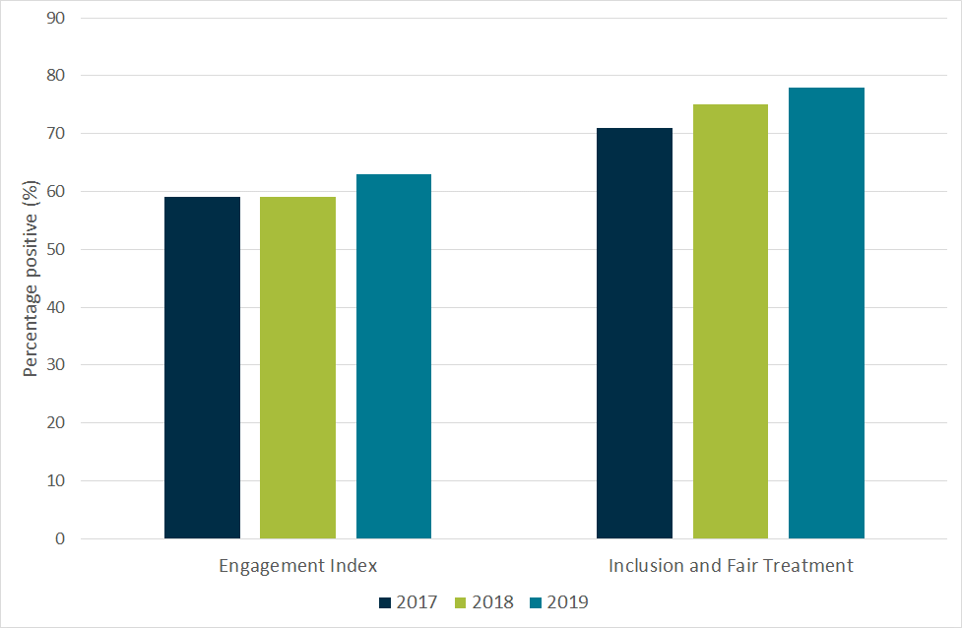

  - Building Field Capability Operational Excellence and Performance Management: an improved approach to allocations, new management information and a focus on time use had positive effects on performance. In 2018, an increase in non-interviewing demands for interviewers led to a decrease in the proportion of time spent interviewing. The new demands offered individual benefits and aligned to the inclusive culture we are building but, combined with introducing and embedding new technology, decreased time available for interviewing. A ‘back to basics’ campaign to support interviewers in reducing the amount of time spent on administration resulted in time spent on interviewing activities increasing by about ten percentage points, as shown in Chart 2.

Chart 2: Interviewer time on interviewing and administration, Apr18 – Mar20
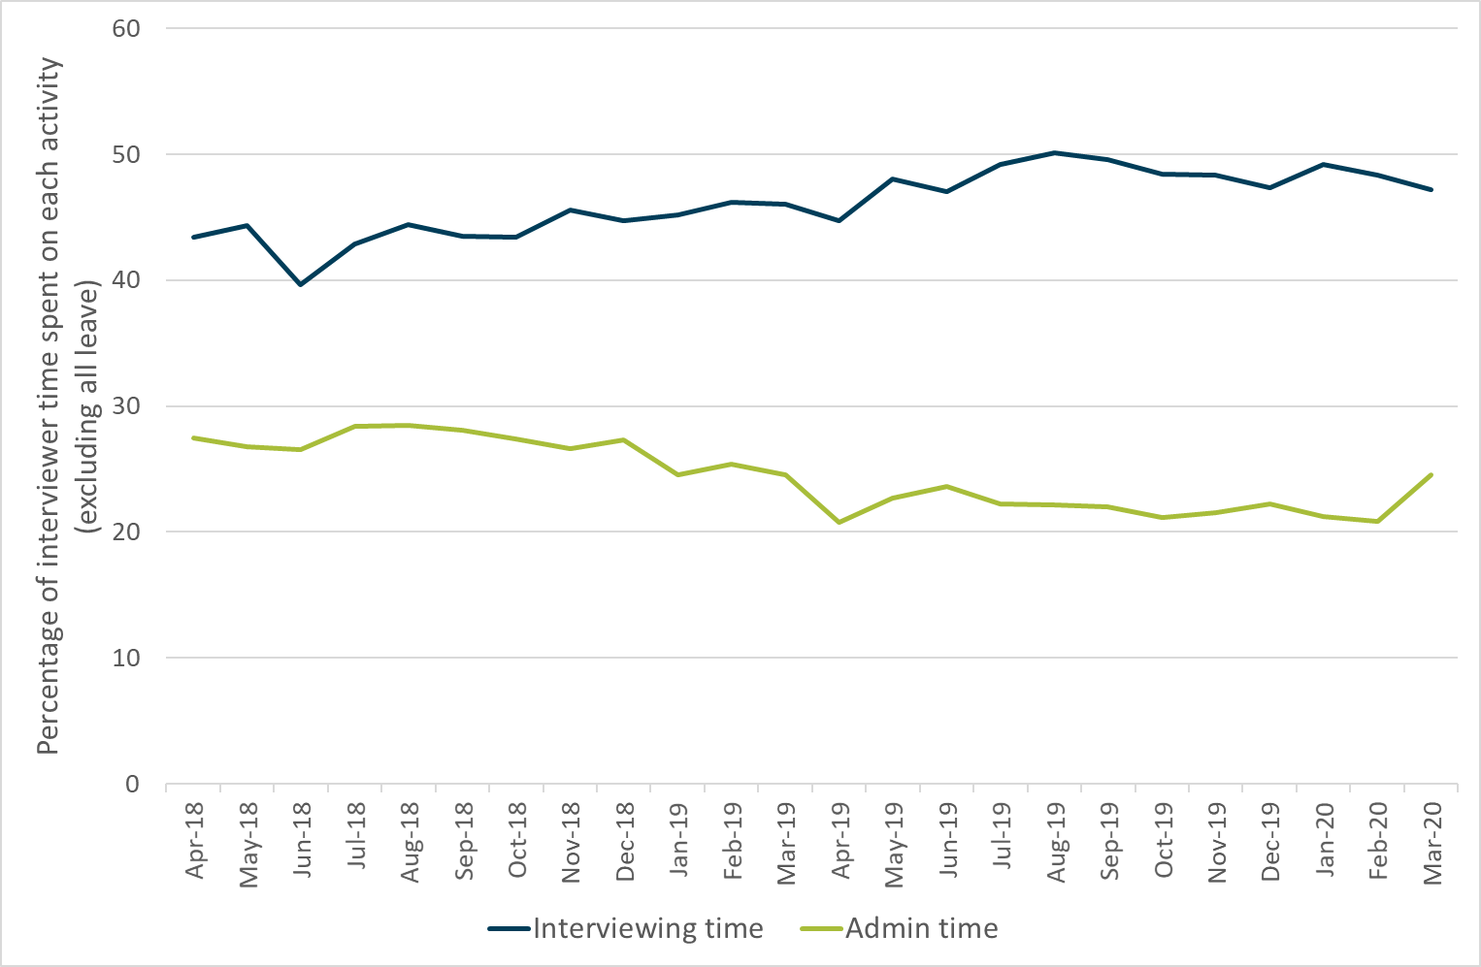

  - Optimising Respondent Engagement Incentives: Academic literature and in-house analysis have shown how incentives can support response rates; we devised an incentives strategy based on this. The main change was the introduction of unconditional incentives for all sampled LFS addresses in May 2017. Statistical analysis estimated that the overall response rate would have been 4.1 percentage points lower if incentives had not been used. This can be seen in Chart 3 by a step change in May 2017. Since data collection has moved to telephone because of COVID-19, some planned incentives changes have been fast-tracked and resulting cost savings used to boost sample sizes and incentive values to help our response to the pandemic.
  - Optimising Respondent Engagement Marketing and Publicity: we have worked with Communications colleagues to raise the profile of social surveys and ensure that we will benefit from the increased effort given to marketing and publicity for the 2021 census. The COVID-19 crisis has been an unexpected boost to public awareness of and trust in ONS, which we have sought to capitalise on in media appearances and through a social media campaign.
  - Transforming Survey Design Moving Online: In November 2019, we started our first live mixed mode (online/phone) survey, the Opinions and Lifestyle Survey. Work to develop online surveys meant ONS was able to respond quickly to COVID-19 to supplement response by setting up online surveys of the labour market and to assess the social effects of the pandemic. Accelerating the transformation of other social surveys will be a priority in the coming year, with online collection used alongside telephone and face-to-face modes.
The Effect on Response Rates of the strategy and of COVID-19
- In the first year of the strategy (2018/19), the desired response rate increases were not achieved. Reasons included the effect of substantial changes to working practices, including for example, the introduction of new technologies for interviewers to manage their work. These, combined with low digital skills among interviewers, led to increased administration time and a number of staff choosing to leave. There was also a blackout of management information during 2018/19 as background system changes were made in ONS. Incentives for LFS respondents (introduced in 2017) continued to boost response by about four percentage points but did not halt its underlying decline or compensate for these factors.
- Response for the period 2017/18 to 2019/20 for Wave 1 of the LFS is shown in Chart 3, along with key events. Apart from the normal seasonal effects of Christmas, and until the response shock caused by COVID-19 in March 2020, the LFS target had been met in nine months out of the year. This was a welcome recovery after the impact of multiple changes depressed response in 2018/19 and an encouraging achievement against the backdrop of a long-running downward trend in response across the survey industry and internationally (de Leeuw and de Heer, 2002, de Leeuw, Hox and Luiten, 2018). This also provides encouraging evidence that the elements of the Response Rate Strategy had been having a positive effect.

Chart 3: LFS response rates and key events April 2017 – March 2020
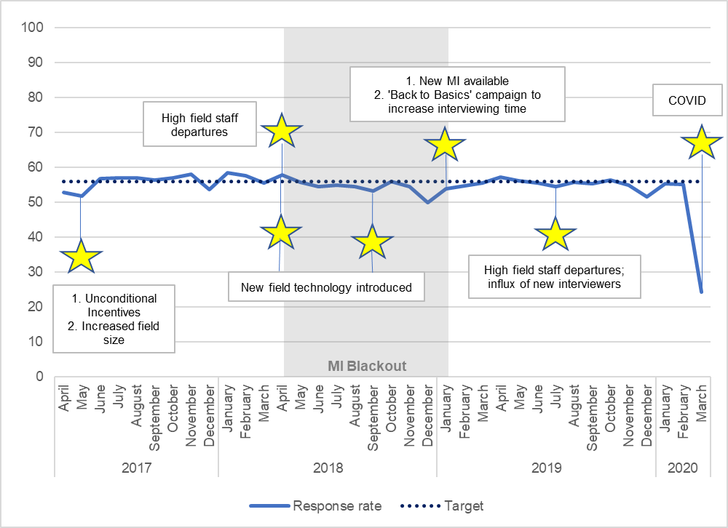

- When government guidance on COVID-19 advised that, “now is the time for everyone to stop non-essential contact with others and to stop all unnecessary travel,” ONS ceased face-to-face data collection immediately in favour of its interviewers working by telephone from home. Technical issues relating to home-working equipment and processes were resolved quickly, but response was affected by the lack of phone numbers for respondents. We responded to this by adding tele-matching of addresses, and later a respondent portal to provide contact details.
- By May 2020, between 45 and 50 per cent of all newly selected addresses had a phone number, either through tele-matching or provided by the respondent to the portal or to the interviewer. This resulted in around a third of newly sampled addresses taking part each week.
- Non-LFS surveys took more of a hit to performance due to COVID-19. They are typically longer and more complex, so it was more difficult to adapt them for telephone collection, for example by shortening questionnaires and removing showcards. Between 25 and 30 per cent of newly sampled addresses typically take part each month now.
What COVID-19 means for the Strategy
- The shock to response of COVID-19 means that the strategy now needs to be re-evaluated in the context of our new working practices and our expectations of how our working practices will be affected in the longer term. Having concentrated on weathering the crisis over the first months of COVID-19, we are now considering what model of data collection we can and should return to and what opportunities the changes present.
- Re-evaluation of the strategy will include maximising telephone number collection to support our interim operating model, and an exploration of Knock-to-Nudge: doorstep visits to collect telephone numbers rather than data. The strategy will also need to adapt to accommodate changes to transformation plans recently agreed. Following the launch of the online labour market study (LMS) as a contingency during the COVID-19 emergency, the priority is to accelerate the replacement of LFS by putting residual content online as well. There is an emerging demand for an online income survey which, combined with surveys now shortened for telephone mode, will be likely to accelerate the transformation of household financial surveys.
Conclusion and priorities going forward
- Based on the discussion above, it can be concluded that the Response Rate Strategy has had a positive effect in maintaining response rates for the LFS and non-financial surveys in 2019/20. Important factors have included:
  - A focus on improving operational procedures.
  - A continued investment in the culture and engagement of the division.
  - Continuing to offer respondents an unconditional incentive to encourage survey participation.
- There are continuing concerns about response rates for financial surveys and about the implications of the COVID-19 pandemic for future data collection practices.
- The reprioritised Response Rate Strategy will be likely to include:
  - Exploring new data collection practices, such as ‘Knock-to-Nudge’, which are safe in the context of COVID-19, to encourage phone or online participation while face-to-face, in-home interviewing is not possible
  - Exploring new sources of telephone numbers (or other respondent contact details)
  - Re-evaluating the requirement for incentives for new data collection practices
  - Fast-tracking the transition of financial surveys to online mode
  - Maximising the benefits of ONS’s raised profile

Discussion
We would like to discuss with conference attendees the following questions:
- What are other organisations’ experiences of the impact of the pandemic on response rates?
- What are other organisations prioritising in their recovery from changes to data collection due to COVID-19?
- In a mixed mode environment, are response rates the best indicator for measuring the success of survey data collection? Are there other measures that are better?

de Leeuw, E., & de Heer, W., (2002). Trends in Household Survey Nonresponse: A Longitudinal and International Comparison. In R.M. Groves, D.A. Dillman, J.L. Eltinge, R.J.A. Little (Eds) Survey Nonresponse, p.p. 41-54 New York: John Wiley & Sons.
de Leeuw, E., Hox, J., & Luiten, A., (2018). International Nonresponse Trends across Countries and Years: An analysis of 36 years of Labour Force Survey data https://surveyinsights.org/?p=10452

